# 

# **Ochre’s Design Thinking Project**

If you care about learning or passing, start your project today by carefully reading every word in this document. According to [this website](https://capitalizemytitle.com/reading-time/2700-words/), it should take 7-25 minutes, depending on your English language proficiency.

However, take your time and let the information sink in; maybe get tea or coffee and settle down to read it. Take notes if you need to.

For the best outcomes, read it twice over.

This document starts by explaining your team project. Your team doesn’t have to complete the tasks in the order shown below but doing so will increase the likelihood of a great design (and therefore a pass for the course).

Once your project has started, place all of the team’s work in this document, for example

* Text
* Links to videos
* Diagrams
* Photographs of sketches
* Screen captures
* etc

If you did something for the project, put it in this document.

No matter what you’re working on, we want to see the work evolve. WE DO NOT WANT TO SEE A FINISHED PIECE OF WORK SUDDENLY APPEAR.

This is a shared document. Share the authorship with your teammates. If you like to take over a Word document, fight that urge.

Why? Because when we assess this document, we will check its version history to see which teammates contributed to it (and which teammates didn’t contribute – those teammates may be failed). We will also check the document’s version history to see when you contributed something substantial (and when you didn’t).

We are going to open this document every now and then and leave comments for you and your team to consider.

## Why do you have to learn design thinking?

Design Thinking is an approach to the design of technologies that enables IT professionals to launch innovations that matter. In other words, innovations that ordinary people are prepared to pay for.

Design Thinking is complementary to traditional IT design methods because it’s agile with a strong focus on people, their problems, and successful innovation. No other IT design method brings these things together.

Being a great design thinker puts you ahead of the crowd and more likely to gain employment after you graduate.

Finally, how long have you worked in the IT industry?

1. If that time is less than 10 years, your opinion on Design Thinking is not yet fully formed.
   1. Instead of closing your mind, open it. Why should you open your mind? Because
      1. People who know more about the industry than you do[1] have decided the course belongs in your program and that it belongs in first year.
      2. If you close your mind, you waste your fees and the opportunity to become someone who can contribute to the IT industry.
      3. Universities are places of learning. Learn things first and then if you must, dismiss them later.
   2. This is a foundation course – get the foundations wrong and nothing works later on.
   3. Why invest talent, money and time in an innovation that other people won’t pay for? It’s a waste. Design Thinking helps you avoid that reputation-destroying outcome.
   4. Technologies are used by people. Being able to understand people is a professional skill that will pay off in time. Design Thinking provides you with various techniques for understanding people.
2. If you have worked in the IT industry for more than 10 years, the relevance of Design Thinking is either clear to you already or it will become clear as you learn more about it. Also, you’re more likely to be convinced by the argument at point i. above.

## Organise the team

1. Each teammate should have completed a Belbin profile. If not, it’s too late to do one now, so start at step 4 below.
2. Assign two Belbin roles to each teammate so that strengths are put to good use and so that teammates have an opportunity to improve their weaknesses.
3. Review Lecture 2 to align the Belbin roles to the six Design Thinking tasks.

Why does the team need Leads and Deputies and everyone else?

There is too much work in this project for everyone to work on the same thing at the same time. Division of labour is essential to finishing on time.

7 teammates working 8 hours a day = 280 hours of productivity in a week.

1. [Optional] Take the time to do a social activity with everyone else in the team because it will forge the team’s unspoken and unwritten social contract, examples
   1. Have a beer together
   2. Share a BBQ or picnic
   3. Go see a movie
   4. Go for a swim at the beach
   5. Go to the footy
   6. Have a karaoke night
   7. Have a gaming session with everyone in the team
2. From your thinking in step 3 above, decide which teammate will be the Lead for which Design Thinking tasks and which teammate will be the Lead’s Deputy.
   1. There are six Design Thinking tasks in this project.
   2. Each Design Thinking task consists of several different pieces of work.
   3. Each Design Thinking task needs a Lead and a Deputy.
   4. That means
      * Six Leads for six Design Thinking tasks.
      * Six Deputies for six Design Thinking tasks.
   5. Make sure everyone is Lead or Deputy at least once.
3. The Lead for each Design Thinking task will
   1. Consider the tutorial learning for their Design Thinking task.
   2. Consult with their Deputy to decide
      * What work needs to be done.
      * Assign different work tasks to different teammates with clear deadlines
        1. The easiest and most transparent way to assign work to teammates is to write the task assignments into this document, where we can see it.
        2. When assigning work to teammates, set an early but reasonable deadline (you can’t complain about late work if you didn’t set a deadline).
        3. You might like to make a special table to keep track of task assignments.
   3. Mentor teammates when they ask for help.
      * If mentoring doesn’t help, refer the teammate to a tutor or Course Coordinator.
   4. Accept completed work from teammates.
   5. Consult with their Deputy to
      * Check teammates’ completed work.
      * Make final changes.
   6. Indicate when work has been finalised by updating the document’s amendments table (below).
4. The Deputy for each Design Thinking task will
   1. Consult with their Lead as noted above.
   2. If the Lead is unexpectedly unavailable, act as Lead.
5. Other teammates will
   1. Accept tasks from Leads.
   2. Complete the tasks immediately.
   3. When necessary, ask the Lead for help (without delay).
   4. Return work to the Lead before the deadline.
      * The easiest and most transparent way to return work to the Lead is to drop the work into this document and update the document amendments table (below).
   5. You can be Lead or Deputy for one part of Design Thinking while at the same time accepting tasks as a teammate from the Lead or Deputy for a different part of Design Thinking.
6. Make a time for the team to hold a daily stand-up meeting.
   1. What’s a stand-up meeting?
      * It’s an agile software development meeting style which is a widely used in the ICT professional practice.
      * It’s a very short meeting (less than 10 minutes).
      * Held every day.
      * Stand-ups provide a lot of transparency and accountability.
      * Everyone says four things.
        1. Their name (this helps us with our assessment of each student’s contribution to the project).
        2. What I did yesterday.
        3. What I plan to do today.
        4. The problems that are preventing my progress are … [and then everyone briefly tries to provide support].
      * If providing support for a teammate will make the stand-up go longer than ten minutes, have the conversation at another time.
      * Always be truthful in the stand-ups, if you’ve been gaming all day, say so (we know it’s a normal part of life).
   2. To support our assessment of your team’s work, video the team’s stand-up meetings.
      * If we can’t see the meetings, we can’t assess them so it’s a guaranteed way to earn a fail.
      * Suggestion: do the stand-ups [using Zoom](https://lo.unisa.edu.au/course/view.php?id=17327&section=1).
        1. One teammate will set up and host the meetings.
        2. The host will set up a recurring meeting with automatic recording stored on the host’s computer.
        3. At the end of each meeting, Zoom will give the host the recording for that meeting.
        4. The host [uploads the recording to YouTube as an ‘unlisted’ video](https://www.youtube.com/watch?v=Go_HDCANWf8).
        5. The host puts a link to the YouTube video in Appendix 1 (below).
      * Or meet face to face and make your own video, figure out how to embed or link it to this document in such a way that we can watch it without any problems.
   3. Link the recordings to this document so we can see who is participating.[2]
      * The recording needs to work when we click on it.

We require links to stand-up meetings only. Your team may decide to hold long meetings *in addition to* stand-up meetings, but we do not have the time to view long meetings.

If you have prepared all the things listed above, your team is ready to start using Design Thinking to make an IT innovation.

* Understand the client’s context
* Empathy
* Define
* Ideate
* Prototype
* Test

And later, your team will prepare and deliver a pitch that showcases the team’s innovation.

## What to do when a teammate isn’t participating

1. Send them an email to see what’s going on and make sure the email is copied to the course coordinator and your tutors.
   1. No reply? Repeat a few days later.
   2. Still no reply? Repeat again a few days later.
   3. Give up and put all the emails and replies (if any) in the special appendix at the end of this document.
2. Re-frame the problem as an opportunity to respect that person’s (bad) choices.
3. Assign their work to someone else.
   1. Don’t forget to set an early but reasonable deadline.
4. If the missing teammate suddenly shows up and asks for work, then
   1. Give them some work to do.
   2. Make sure the deadlines are sufficiently long enough to complete the tasks.
   3. Also make sure the deadlines are sufficiently short enough to allow time for work re-assignment in the event the teammate disappears again.
5. But what about the marking?
   1. We will read this document, its amendments table, and its version history to see who wrote which parts.
   2. We will watch the videos of your team’s daily stand-up meetings to see who participated.
   3. So, your grade is not strongly connected to other people’s grades.

## How to use this document

All of your team’s Design Thinking work belongs this document, including the team’s organisation.

Working on a task? Do the work in this document and when you’re finished, update the document amendments table, and tell the task Lead it’s ready for checking.

We’re going to open this document from time to time and write comments if

* The team has done something really well.
* The team has gone on the wrong track.
* We’re amused by something the team has done.
* Etc.

Reminder, we want to see each work item evolve.

Design Thinking is a cheap and effective but quick and messy method for designing innovations. If this document gets messy, that’s a good thing, but you can support us in assessing it by including a Table of Contents once it’s finished.

## How to do the project

Participate2 in your tutorials.

The design activities you are invited to consider in your tutorials may be applied in the project.

For example, the first Design Thinking topic in the tutorials is Understanding the Client’s Context (UCC). In that topic’s tutorial, you are invited to consider 6 different analytical techniques.

1. SWOT.
2. PESTEL.
3. Porter’s 5 forces.
4. Blue Ocean Strategy.
5. Morgan’s Metaphors.
6. Rich pictures.

The Lead for UCC will

* Consider these techniques.
* Decide which ones are suitable for the project’s clients.
  + Assign these techniques to teammates to work on.
* Write their reasons for rejecting the other techniques into in this document.

The same process applies to Empathy, Define, Ideate, Prototype, and Test.

In this way, every technique from the tutorials is included in the document, even if a technique was rejected by its Lead.

## How are we going to assess your team project?

We assess **your participation in the team**. This is an individual pass/fail.

* Your contributions to this document.
* Your participation in your team’s stand-up meetings.
* Your participation in your team’s project checkpoints.

We assess **your team’s pitch**. This mostly a team pass/fail. To pass, you need both of the following

* Participate in your team’s pitch.
* The whole pitch must be considered a pass by the tutors who are assessing it.

We assess **your design thinking expertise in an interview**. This is an individual pass/fail.

* We will ask a variety of questions.
* The understanding, insight and clarity demonstrated in your answers will be assessed.

## When are the different topics taught?

Here is a rough guide to the course; note that this schedule may be changed if unforeseen circumstances arise. To stay informed of changes, always immediately read

* The course’s Announcements.
* Emails sent from the Course Coordinator.

Remember: participation means listening to what others say and speaking when it’s your turn. We don’t assess attendance; instead we value what you say and do, which we consider through our assessment of your learning.

|  |  |  |  |  |  |  |
| --- | --- | --- | --- | --- | --- | --- |
| **Week** | **Classes** | | **Assessments** | | | |
| **Lecture** | **Tutorial** | **Workshop** | **Online activities** | **Team project** | |
| 1 | Course overview |  |  | Belbin profile |  |  |
| 2 | Design thinking overview |  |  |  | Team allocation |  |
| 3 |  | Teamwork | Participation | PLAs & CTA | Belbin role leads | Daily stand-up meetings |
| Cultural training | Participation |  | Design thinking task leads and deputies | Daily stand-up meetings |
| Understanding the client’s context (UCC) | Participation |  | UCC | Daily stand-up meetings |
| Empathy | Participation | Prep for client discussion | UCC & Empathy | Daily stand-up meetings |
| 4 | Client discussion | Define | Participation |  | UCC & Empathy | Daily stand-up meetings |
| Project checkpoint | Participation |  | Empathy & Define | Daily stand-up meetings |
| Ideate | Participation |  | Define & Ideate | Daily stand-up meetings |
| Prototype | Participation | Plan the pitch | Ideate & Prototype | Daily stand-up meetings |
| 5 |  | Project checkpoint | Participation |  | Prototype | Daily stand-up meetings |
| Test | Participation | Prototype & Test | Daily stand-up meetings |
| Careers | Participation | Prototype, Test, write & rehearse pitch | Daily stand-up meetings |
| Project checkpoint | Participation | Careers quizzes | Test, write & rehearse pitch | Daily stand-up meetings |
| Mid-semester break | | | | | | |
| 6 |  | Pitches |  | Ethics analysis | Assessed during tutorials | Daily stand-up meetings as needed |
| Interviews |

## Got questions?

Use the Q&A forum on the course website.

If it’s a private question, send email to one of your tutors or to the Course Coordinator.

## Project’s finished?

Double check that the team organisation section is clear and that every technique from the tutorials is in this document (even if you didn’t use a technique, as specified above, the Lead should explain why it wasn’t used).

Do you want to check the headings in the document? Might be a good idea.

Submit the document on the course website before your team’s pitch. It will be checked for plagiarism.

The submitted document has to be identical to the document on OneDrive and there must be no questionable last minute edits, eg, do not add or remove historic information from the Document amendments table because that table needs to correlate to the document’s revision history on OneDrive.

## How to pass

Follow all the advice provided in this document and on the course website.

Keep your team organised.

When a task lead (or deputy) gives you a task, do it immediately, put it in this document, then update the document amendments table.

Participate fully in your team’s tutorials so that you know what to do in the project.

Regularly attend your team’s daily stand-up meetings.

When you attend your team’s daily stand-up meetings, participate fully.

Try to produce a genuinely ground-breaking innovation.

Work hard on your part of the pitch.

Participate in your team’s interview.

In short, respect yourself, your team, your client, and your learning.

## How to fail

No sign of gradual work in this document? That’s a Fail for the whole team for the whole project.

No focus on the client? That’s a Fail for the whole team for the whole project.

Same innovation as another team? That *could be* Fail for the whole team for the whole project.

You didn’t participate in the pitch? That’s a Fail for you for the pitch.

You didn’t participate in the interview? That’s a Fail for you for the interview.

Your answers were sketchy in the interview? That *could be* a Fail for you for the interview.

The team’s shared document includes words copied from the internet or elsewhere? This is academic misconduct and the team’s pass/fail will be determined after the academic integrity conversations have concluded.

Fair warning: if someone in the team copied material from elsewhere instead of making it from scratch, there is a really good chance the whole team will get a fail.

Now, this is your document, so give it some character and spend a few weeks showing us how brilliant you can be!

## Document amendments

|  |  |  |  |  |  |
| --- | --- | --- | --- | --- | --- |
| **Date** | **The amendment** | **Who made the amendment?** | **Lead** | **Amendment accepted on** | **Amendment accepted by** |
| 1/6/2020  2/09/2020  04/09/2020 | This amendments table was added  Added tables for PLAs, CTAs, Belbin scores  Added PLAs, Belvin scores | Phil Ingerson  Regina Wilson    Rojina Sharma |  | 2/6/2020 | Alice Crowley (deputy) |
| 4/09/20  7/09/20  8/09/20  9/09/90  14/09/20  15/09/20  16/09/20  17/09/20  18/09/20  4/09/2020  4/09/2020  5/09/20 | Added group video  Added two articles of research  Added SOAR as a possible tool to use  Began glossary page | **Harpuneet**  **Singh**  Regina  Wilson  Regina Wilson  Regina Wilson |  |  |  |
| 6/9/2020 | Table showing best Belbin data for tasks | Regina Wilson |  |  |  |
|  |  |  |  |  |  |
| 6/9/2020 | Questions posted on assessment link (also shown on this document) | Regina Wilson |  |  |  |
| 7/9/2020 | “Creating Frameworks” from IDEO to frame the problem | Regina Wilson |  |  |  |
|  |  |  |  |  |  |
|  |  |  |  |  |  |
| 9/9/2020 | Added tasks learned during Tutorial. | Harpuneet  Singh |  |  |  |
|  |  |  |  |  |  |
| 9/9/2020  9/09/2020 | Added table for tasks learned during tutorials  Begun analysis of client video looking at pain points and successes/ opportunities | Regina Wilson  Regina Wilson |  |  |  |
|  |  |  |  |  |  |
| 9/9/2020  10/09/20 | Added PLAs and Belbin profile scores  Added information about the SAASTA program | Deshan  Bandara  Regina Wilson |  |  |  |
|  |  |  |  |  |  |
| 10/9/20 | Added problem solving approaches to the table | Fatih Kaan Beyaz |  |  |  |
|  |  |  |  |  |  |
| 10/09/20 | Added  Importance 5 stage of design thinking | Rojina Sharma |  |  |  |
|  |  |  |  |  |  |
| 10/09/20 | Added Important Information of Stage 2 Design Thinking: (DEFINE) | Rojina Sharma |  |  |  |
|  |  |  |  |  |  |
| 10/9/20  10/09/20 | Added information regarding Stage 3 (Ideate)  Added Important Information of Stage 5 Design Thinking: (TEST) | Fatih Kaan Beyaz  An Truong |  |  |  |
| 10/09.20 | Added Information on  (Problem Statement) | Rojina Sharma |  |  |  |
|  |  |  |  |  |  |
| 10/9/20 | Added tool (rich pictures) to analyze the client | Fatih Kaan Beyaz |  |  |  |
|  |  |  |  |  |  |
| 10/9/20  10/09/20 | Pain points  Added information on Soar analysis, Porters 5 forces, PEST Analysis | Angela Sheppard  Deshan  Bandara |  |  |  |
|  |  |  |  |  |  |
|  |  |  |  |  |  |
| 10/10/20  11/09/20  12/09/20  12/09/20  13/09/20  14/09/2020 | Persona  Prototype  Added information on paper prototyping with links to a video  Added more analysis from client video and began a SWOT analysis of this  Begun an empathy map from the client video  Added the I Love Algorithms cards  Did the analysis of the client and added the pain points | Angela Sheppard  Regina Wilson  Regina Wilson  Regina Wilson  Regina Wilson  Fatih Kaan Beyaz |  |  |  |
|  |  |  |  |  |  |
|  |  |  |  |  |  |
| 14/09/2020 | I posted my problem statements from the pain points I posted | Angela Sheppard |  |  |  |
| 14/09/2020  14/09/2020  15/09/2020  15/09/2020  15/09/2020  19/09/2020  19/09/2020  20/09/20  22/09/20  22/09/20  22/09/20  23/09/20  29/09/20  02/10/20 | I analysed my problem statements and am currently thinking of a solution to share to the team.  Started working on Prototyping  Table to indicate if team members would rather use a paper prototype or digital prototype  Team Discussion on problem statements  Stage 2 defining stage  Stage 3 ideate stage  Empathy Mapping  Pitch  Filled SWOT analysis  Added Client Persona  Ethics Principle and empathy with journey map  Organized the document  Problem statements- Page 49  Digital Prototype & Interactive Prototype | Angela Sheppard  Deshan Bandara  Angela Sheppard  Written by Angela but participated by whole team  Written by Kaan but participated by whole team.  Written by Kaan but participated by whole team.  Written by Deshan  Contributed by whole team  Harpuneet  Harpuneet  Harpuneet  Rojina Sharma  Fatih Kaan Beyaz  Harpuneet  An Truong |  |  |  |

**Glossary and Acronyms:**

If, like me you forget what the acronym stands for, then let’s add to this glossary, so we don’t need to keep asking!!

**PLA:** Personal Learning Agreement

**CTA:** Collective Team Agreement

**EDSAS:** An enrolment management system used by The Department of Education.

**Day Map:** An online database system that allows teachers to mark student attendance/ absentees. Students and parents can also view their attendance /absentees. This data base also provides the teacher and student timetable, so that a student can find where a teacher might be and vice-versa.

**SAASTA: S**outh Australian Aboriginal Secondary Training Academy (SAASTA) provides Aboriginal high school students with a unique sporting and educational program.

**SACE:** South Australian Certificate of Education

**VET:** Vocational Education Training: Vocational education and training (VET) enables students to acquire skills and knowledge for work through a nationally recognised industry-developed training package or accredited course.

**Team organisation/profile**

**TEAM VALUES:**

* Kindness
* Empathy
* Open-mindedness
* Respect

|  |  |
| --- | --- |
| **Name** | **PLAs** |
| **Regina** | * Not talk so much or be off topic. * Stay connected with the group. (Despite talking too much I’m an introvert and I tend to want to withdraw and do things by myself. I don’t want to take over, but I like working on my own and find that I work better on my own.) * Be a peer. Be part of the group as on an equal level—as student who is also learning. But be willing to share experience if appropriate. * Not try to be team negotiator or try to always patch things up. * Show up, be on time, complete work when I said that I would and be an active part of the team. |
| **Harp** | * Work with the team to finish given tasks and not fall behind or let the team down. * Help a teammate who is falling behind. Either in person or through email/zoom. * Ask questions on topics I don’t understand, or I'm stuck on. * Listen and not talk over when someone in the team is talking or trying to get their point across. * Be creative and original. |
| Angela | * Buddy System: This would help those who are a lot more introverted. * Daily/weekly goals: This helps the team keep on track and motivated to continue with work. * Communication: Daily communication through in person and online. Zoom will make it easier to record meetings with other people in the group * Listening: Letting the team choose if they want to be assigned to their strengths or work on their weaknesses through the project. * Reliability: Similarly, to the buddy system, each member has to be respectful and reliable to the other team members and contribute accordingly. |
| Rojina | * Good Communication: Good communication between team is the KeyPoint for the successful Teamwork. Being a good communicator also means being a good listener. By listening to your Team member, you show them respect, which is an essential trust-building method. Offering encouragement also goes a long way to getting the best out of team members. Collaborating and being open to new ideas are also essential ingredients for a harmonious team environment. * Respecting Everyone’s ideas: Everyone have different perspectives and new ideas, sometime one idea is not enough and if we listen to all team members ideas and choose one of the best will give the best result. * Being Punctual: I will do my work on time without any delay and be the active, responsible. * Delegation: Teams that work well together understand the strengths and weaknesses of each team member. One of the benefits of strong teamwork is that team leaders and members are adept at identifying all aspects of a project and allocating tasks to the most appropriate team members. * Build Trust with everyone in Team: Trust is the currency of an effective team. Team members must trust each other to achieve outstanding teamwork. |
| **An** | * *Being punctual*: It’s responsibility of every members as well as myself to complete tasks on time and still maintain the quality of work * *Willing to listen*: Even though I’m not really a talkative person, I see myself pretty good at listening others and hopefully it could helpful * *Being responsible with my own role & tasks*: Make sure that every task needed to be done no matter how the situation is going * *Being creative* |
| Kaan | * **Being punctual** (If every team member shows up at the meetings on time or does not miss any deadlines, the team can operate smoothly.) * **Being an active team member** (Everyone should contribute to the team’s work, and we should share our ideas without feeling any pressure.) * **Being kind and understanding** (If someone miss the deadline or does not do their work, there might be some personal issues the member has. Therefore, we should be understanding and give them another chance.) * **Having good communication skills** (The better the communication is in the team, the better the product will be. Also, everyone should be a good listener.) * **Being open-minded** (We should be open to new ideas, and we should not be dwelling on the ideas we only have. If the idea is going to benefit the team more, then we should give it a go.) |
| Deshan | * **Maintaining your punctuality all over the course -** Each member needs to maintain their punctuality all over the course in attending the tutorials, stand up meetings, submitting assignments etc. * **Make your fullest contribution to each meeting and get the maximum out of them -** Since this is a group project its bit hard to attend to meetings all members at once with their commitments and we should try our best to meet all maximum possible while taking the maximum for our career development. * **Be open and make honesty as the best policy -** Each group member has the right to express their ideas with others and everyone needs to be truthful in group activities. * **Do your best for every activity during the course -** Success of this group project is depend on the contribution of all members therefor everyone needs to give their fullest for the betterment of the group. * **Respect each other during the team activities -** Respecting each other will create automatically a pleasant environment for everyone and then members will do their maximum to the group. |

|  |  |  |  |  |  |  |  |
| --- | --- | --- | --- | --- | --- | --- | --- |
| **CTAs** | **We agree to...** | | | **And in practice this might mean...** | | | |
| 1 | Punctuality | | | * If for any reason you will be late, or can’t attend, please communicate. * Let’s be kind to each other, in that we all have commitments that will get in the way occasionally of our ability to be punctual. Also, there are often things that are outside of our control, such as delayed trains or traffic or roadworks. * But, we will, as a team, approach and speak with compassion and empathy, to anyone who is consistently late or absent, as they may need support. | | | |
| 2 | Open-mindedness | | | * Use a buddy system to support each other. There will be times where we will feel out of our depth and may need to rely on others to get through that part, so we will support each other recognising that we are all learners. * Respecting everyone’s ideas. No idea should be rejected until it has been looked at. Every idea, no matter how off-the-wall, left-of-centre, weird or out-there should be ignored. Who knows, that weird, seemingly ‘simple-stupid’ idea could be the one that turns out to help us develop an amazing plan!! * Listening. There is a big difference between hearing and listening. We will all try to listen to what each member has to say with open minds, open hearts, kindness and empathy. We will seek clarification (see next PLA) if needed. * Giving the space for all members to contribute. Some of us are talkers, and while we don’t mean to, we can dominate the meeting times. So, for those of us that talk a lot (see next PLA), we need to step back, be quiet and give space to those who are the quieter thinkers. | | | |
| 3 | Good communication | | | * Listening. We, as a group believe that listening is important and that is why we have put it twice in our PLAs. * Each of us is responsible to stay informed of what is happening in the group. (This is also where a buddy system can be used). If we are unable to attend a meeting, then we need to view the recording and if we have any questions or ideas or differences of opinion, then it is our responsibility to communicate with the group at our next available opportunity. * We, as a group, have vowed to deal with any conflict in appropriate and kind ways. | | | |
| 4 | Consistency | | | * Everyone to make a contribution to every section, no matter how small. Your contribution could just be editing; or providing some feedback; or sharing a joke or a video or an article. * Everyone to contribute ideas to each section (as we did for this section in our first workshop). * As a group, we will breakdown each section into bite-sized goals that each member can work on. * Consistency also aligns with punctuality and attending meetings. | | | |
| Name | | Belbin score | | | Analysis | | Task & Role |
| **Regina** | | Implementer: 0.8  Co-ordinator: 0.93  Shaper: 0.5  Plant: 1.125  Resource Investigator: 0.8125  Monitor/ Evaluator: 1.05  Team Worker: 1.042  Completer/ Finisher: 0.5 | | | My strongest Belbin score is **Plant**, followed by **Monitor Evaluator** and then **Team Worker.**  My weakest are Shaper and Completer/ Finisher, followed by Implementer. | | Empathy Lead  Context Deputy  Ideate Deputy |
| **Harp** | | Implementer: 1.35  Co-ordinator: 1.28  Shaper: 1.25  Plant: 0.5  Resource Investigator: 1.81  Monitor/ Evaluator: 0.45  Team Worker: 0.62  Completer/ Finisher: 1.0 | | | My stronger Belbin score is **Resource investigator** closely followed by **implementer, Co-ordinator** and **shaper.**  My weakest points are – Plant, Monitor/ evaluator and Teamwork. | | Ideate Lead  Prototype Deputy |
| **Angela** | | Implementer: 0.85  Co-ordinator: 1.35  Shaper: 1.18  Plant: 1.06  Resource Investigator: 1.18  Monitor/ Evaluator: 0.65  Team Worker: 0.87  Completer/ Finisher:1.07 | | | My strongest Score in the Belbin Self-Perception inventory test was **Co-ordinator**; Thus, leaving shaper, resource investigator, completer/ finisher and plant respectively.  Contrastingly my weakest skills are Monitor/ Evaluator, implementer and Team Worker respectively. | | Prototype Lead  Lead Deputy |
| Rojina | | Implementer: 0.95  Co-ordinator: 1.35  Shaper: 1.25  Plant: 0.87  Resource Investigator: 1.06  Monitor Evaluator: 0.9  Team Worker: 0.75  Completer/ Finisher:1.07 | | | My strongest score in the Belbin:   * **Co-ordinator** * **Shaper** * **Resource investigator** * **Completer/ Finisher**   My weakest score in Belbin:   * Monitor/ Evaluator * Implementer and plant * Team worker | | Empathy lead  Context Deputy  Defina Deputy |
| **An** | | Implementer: 1  Co-ordinator: 1.14  Shaper: 1  Plant: 1.125  Resource Investigator: 0.875  Monitor/ Evaluator: 0.5  Team Worker: 1  Completer/ Finisher: 1.57 | | | My Belbin score in order:   1. **Complete Finisher** 2. **Co-ordinator**   My weakest is:  Monitor/ Evaluator | | Test Lead  Empathy Deputy |
| Kaan | | **Implementer:** 1.1  **Co-ordinator:** 2.14  **Shaper:** 1.1  **Plant:** 1.1  **Resource Investigator:** 1.5  **Monitor/ Evaluator:** 0  **Team Worker:** 0.58  **Completer/ Finisher:** 1 | | | My strongest score in the Belbin is:  **Co-ordinator: 2.14**  And my weakest score in the Belbin is apparently:  **Monitor/ Evaluator: 0** | | Define Lead  Ideate Deputy |
| Deshan | | **Implementer:** 1.1  **Co-ordinator:** 1.14  **Shaper:** 0.75  **Plant:** 1.25  **Resource Investigator:** 1.37  **Monitor/ Evaluator:** 0.5  **Team Worker:** 0.67  **Completer/ Finisher:** 1.57 | | | * My Strongest Belbin scores   -Completer/ Finisher: 1.57  -Resource Investigator: 1.37  -Plant: 1.25   * My weakest Belbin scores   **-**Monitor/ Evaluator: 0.5  -Team Worker: 0.67  -Shaper: 0.75 | | Context Lead  Prototype Deputy |
| Task | Best Belbin data | | | Possible Team Members based on Belbin data  Please put yourself forward for lead or deputy. | | | |
| Context | Resource Investigator  Completer/ Finisher  Monitor/ Evaluator  Team Worker | | | An  Kaan  Harp  Regina  Deshan | | | |
| Empathy | Plant  Implementer  Co-ordinator  Monitor/ Evaluator  Team Worker | | | Regina  Angela  Kaan  Rojina  Harp  An | | | |
| Define | Resource Investigator  Monitor/ Evaluator  Team Worker | | | Harp  Kaan  An | | | |
| Ideate | Plant  Co-ordinator  Shaper | | | Regina  Kaan  Angela  An | | | |
| Protype | Implementer  Plant  Shaper  Completer/ Finisher | | | Regina  An  Angela  Rojina  Harp  Deshan | | | |
| Test | Implementer  Shaper  Resource Investigator  Completer/ Finisher | | | An  Rojina  Harp  Deshan | | | |
| **Design Thinking Task + Lead and Deputy** | | | **Individual Tasks for each Design Thinking Task** | | | **Team Member/s doing tasks** | | |
| Context  Lead: Deshan  Deputy: Regina + Rojina | | | * Research on client * Questions for client * Attending client interview * Analysis of client interview * SWOT * PEST * Porters 5 Forces * Blue Ocean * Morgan’s Metaphors * SOAR | | | * Harp; Regina * Harp; Regina; Kaan; An * Harp; Regina; Rojina; An; Angela; Kaan * Whole team * Regina * Deshan * Deshan * Deshan | | |
| Empathy  Lead: Rojina + Regina  Deputy: An | | | * Analysis of client interview * Empathy Map * Personas * Journey Map | | | * Whole team * Regina * Harp * Rojina | | |
| Define  Lead: Kaan  Deputy: Rojina | | | * How to define a problem * The importance of defining a problem * The techniques and types of defining a problem | | | * Kaan * Rojina | | |
| Ideate  Lead: Harp  Deputy: Kaan + Regina | | | **-Kaan**  **Approaches to creative problem solving:**   * **TRIZ** (theory which are derived from tools such as ARIZ or TRIZ contradiction matrix) * **Creative Problem-Solving Process (CPS)** (complex strategy, also known as Osborn-Parnes-process) * **Lateral thinking process**, of Edward de Bono * **Six Thinking Hats**, of Edward de Bono * **Herrmann Brain Dominance Instrument** – right brain / left brain * **Brainstorming and Brainwriting** * **Think outside the box** * **Business war games**,for the resolution of competitive problems * **SWOT analysis** * **The method USIT of convergent creativity** * **Thought experiment** * **Five Ws** * **SOAR**   As a group, we will find one of the most suitable approaches listed on the left side for our project. | | | * Harp * Kaan * Regina | | |
| Prototype  Lead: Angela  Deputy: Harp + Deshan | | | * Drafting the presentation | | | * Angela; Harp * Deshan | | |
| Test  Lead: An  Deputy: Angela | | | * Making sure the presentation is presentable and HD standard | | | * An; Angela | | |

|  |  |  |  |  |
| --- | --- | --- | --- | --- |
| **NAME** | **ROLE** | **TASK/S** | **COMPLETION OF** **DATE** | **Y/N** |
| Group | Group effort | Complete PLAs and CTAs | Fri 4/09/20 | **Y** |
| Group | Group effort | Questions to ask client | 9 am Mon 7/09/20 | **Y** |
| Group | Group effort | Allocate/ volunteer for one of the six Design Thinking tasks as a Lead or Deputy | Tuesday 8/09/20 | **Y** |
| Group | Group effort | Analysis of client interview/ video | Friday 11/09/20 | **N** |
| Group | Group decision | Problem statement | Friday 11/09/20 | **N** |
|  |  |  |  |  |
|  |  |  |  |  |

**Design Thinking Task: Context**

**Understanding our client’s context:**

**Resources/ Research on Client Background and Other Information to Help in Our Design Thinking Process**

**Regina:** Here’s the pamphlet about the Tirkanthi Centre, which Harp has described below. I will send this as an attachment through email. There is also a PDF doc detailing the support structures for the Aboriginal students, which I will email. This may help to inform us in asking the first set of questions.

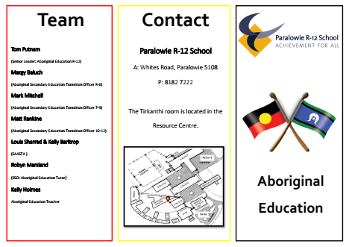

**Regina:** Here is some further information about the client:

<https://studentwellbeinghub.edu.au/educators/illustrations-of-practice/partnerships-and-support/>

**Regina:** Here is a link to a resource about creating a culturally safe place for Aboriginal children: <https://studentwellbeinghub.edu.au/educators/resources/cultural-safety-for-aboriginal-children/>

**Regina:** An article on how to support students who have a disability to better access online learning. Though this is aimed at university students, the article presents some important ideas that can be appropriate to any student who has a disability:

**Regina:** In the client interview the SAASTA program for secondary school Aboriginal students was mentioned. Here is a link to the Department of Education web page giving information about this program: [SAASTA Program for Aboriginal Secondary School Students](https://www.education.sa.gov.au/teaching/projects-and-programs/saasta/about-saasta)

Link to a video about the program [SAASTA Video](https://www.youtube.com/watch?v=O6LQbqoz1-I#action=share) Another video about SAASTA telling the story of a student [A YEAR IN THE LIFE OF A SAASTA STUDENT](https://www.youtube.com/watch?v=zdLTjSIyxlw)

This link is to IDEO: <https://www.ideo.org/> Which is an organisation that has ‘human-centred’ design as its core value. It’s a great resource and I have done one of the online courses in the past on human-centred design. A long time ago by the way, so I have forgotten much of it as I haven’t really used it in my life. But I do know that this website is informative. I have a PDF copy of the Design Kit book from this website, which I will send to you all via email.

Link to the IDEO website with some ideas on how to conduct an interview: <https://www.designkit.org/methods#filter>

One of the ways was conversation starters: <https://vimeo.com/105171459>

I like the idea of being creative in how we conduct the interview, rather than just turn up with a bunch of questions and ask them one after another!! So, let’s be creative in how we go about doing our interview and we could turn it into a fun activity.

Here’s another one: The Five Whys: <https://www.designkit.org/methods/the-five-whys>

You can have a look at the link before you prepare your questions. <https://www.toptal.com/designers/product-design/design-thinking-great-questions>

Article on Indigenous design perspectives: <https://pursuit.unimelb.edu.au/articles/q-amp-a-the-indigenous-design-perspective>

**An**

I’ve just found some articles that you might want to check out about customers' needs (there’re 16 types of needs and how to deal with them)

<https://blog.hubspot.com/service/customer-needs>

<https://www.digiteum.com/understanding-client-needs>

As next week we’re about to learn Design Thinking: Definition in Tutorial 5, there’re some outline that I found helpful for everyone to set up a better view on the process of design thinking and what we are going to learn:

*The Define stage will help the designers in your team gather great ideas to establish features, functions, and any other elements that will allow them to solve the problems or, at the very least, allow users to resolve issues themselves with the minimum of difficulty. In the Define stage you will start to progress to the third stage, Ideate, by asking questions which can help you look for ideas for solutions. This is where you will analyse your observations and synthesise them in order to define the core problems that you and your team have identified up to this point. You should seek to define the problem as a problem statement in a human-centred manner.*

<https://www.interaction-design.org/literature/article/stage-2-in-the-design-thinking-process-define-the-problem-and-interpret-the-results>

**CLIENT INTERVIEW QUESTIONS:**

**Regina’s questions:**

Taking the idea from the IDEO Filed Guide to Human-Centred Design, I would begin by asking some general questions, such as:

* How do you correctly pronounce the name Tirkanthi?
* Could you please inform us about appropriate behaviour, communication, titles and any other information that you think we need to know in order to learn more about you.
* Could you please tell us about who you are?
* Could you please where you come from?
* Could you please tell me about your background and history?
* Could you please tell us what it is that you do and how you do it?
* What are your values?
* In an idea world, what would your vision for Indigenous education be and what would be the ideal wellbeing support for Aboriginal students that come to Tirkanthi?
* We have read that the Australian Federal Government has announced a A$200 million Indigenous Youth Education package and wonder what this means for Tirkanthi?

**Kaan’s questions:**

* During the ACUP cultural training, the speaker had mentioned that as he got older, he realized that it was hard for him to fit in the one of the either worlds truly, so he was struggling. How do you prevent this from happening to your students whose mother’s or father’s background is not Aboriginal?
* Do you have a data store where you can evaluate the previous year? Or what techniques currently are you using to evaluate the education year in order to progress?

**An’s questions:**

1. What is the most inspiring story across the history of Tirkanthi (about students or any specific events)?
2. What are the technological problems that Tirkanthi is having?

|  |
| --- |
| **Team Ochre’s ten questions for the client and the top five:** |
| Ochre Group: Our top 5 is highlighted in bold   1. What role can your education system play in supporting that vision for young Aboriginal students? 2. **How are you closing the gap that exists between aboriginal and non-aboriginal students in the real world?** 3. How do you correctly pronounce the name Tirkanthi and could you please tell us about who you are? 4. Could you please tell us what it is that you do? 5. **In an idea world, what would your vision for Indigenous education be and what would be the ideal well-being support for Aboriginal students that come to Tirkanthi?** 6. **We have read that the Australian Federal Government has announced a A$200 million Indigenous Youth Education package and wonder what this means for Tirkanthi?** 7. **During the ACUP cultural training, the speaker had mentioned that as he got older, he realized that it was hard for him to fit in the one of the either worlds truly, so he was struggling. How do you prevent this from happening to your students whose mother’s or father’s background is not Aboriginal?** 8. Do you have a data store where you can evaluate the previous year? Or what techniques currently are you using to evaluate the education year in order to progress? 9. **What is the most inspiring story across the history of Tirkanthi (about students or any specific events)?** 10. What are the technological problems that Tirkanthi is having? |

**Harp:**

**Adding definitions to the following we learnt in class. \*\***Please add on what you personally learnt from these topics.

**SWOT:** SWOT analysis is a strategic planning technique used to help a person or in this case a school to identify strengths, weaknesses, opportunities and threats (if any).

Image form: Wikipedia explaining what SWOT stands for.

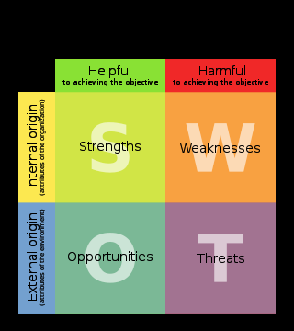

* ***S****trengths*: characteristics of the business or project that give it an advantage over others.
* ***W****eaknesses*: characteristics of the business that place the business or project at a disadvantage relative to others.
* ***O****pportunities*: elements in the environment that the business or project could exploit to its advantage.
* ***T****hreats*: elements in the environment that could cause trouble for the business or project.

**PESTEL:**  is a framework or tool used by mostly marketers to analyse and monitor external factors that can have an impact on an organisation.

We could use this to see if we can identify any factors from other schools or Government bodies that will affect our Client.

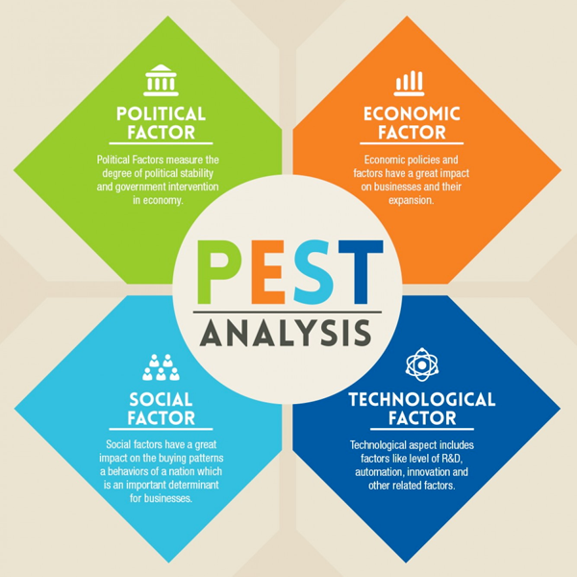

**Porter’s 5 forces:** This analysis model focuses on business that are run purely to make profit, retail giants, big brands use this frequently measure competition.

Don’t see this too relevant to our client as they aren’t in market competing other schools for big profits.

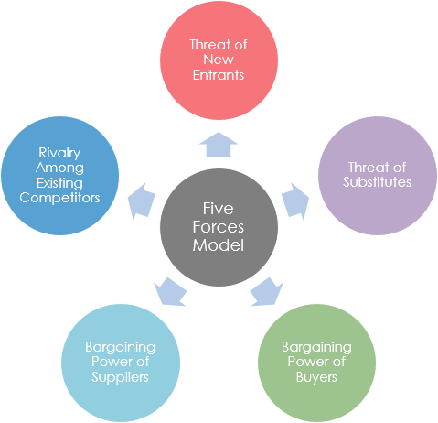

**Blue Ocean:** is a strategy that is about creating and capturing uncontested market. Bringing a new product in the market where demand is high and no competition.

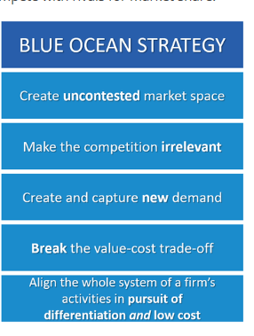

**Morgan’s metaphors:**  Gareth Morgan explains eight metaphors for an organisation.

* **Organism**: an organization is a collective response to its environment and, to survive, must adapt as the environment changes
* **Brain**: an organization is a set of functions designed to process information and learn over time
* **Cultural System**: an organization is a mini society, with its own culture and subcultures defined by their values, norms, beliefs, and rituals
* **Political System**: an organization is a game of gaining, influencing, and coordinating power
* **Psychic Prison**: an organization is a collection of myths and stories that restrict people’s thoughts, ideas, and actions
* **Instrument of Domination**: an organization is a means to impose one’s will on others and exploit resources for personal gains
* **Flux and Transformation**: an organization is an ever-changing system indivisible from its environment

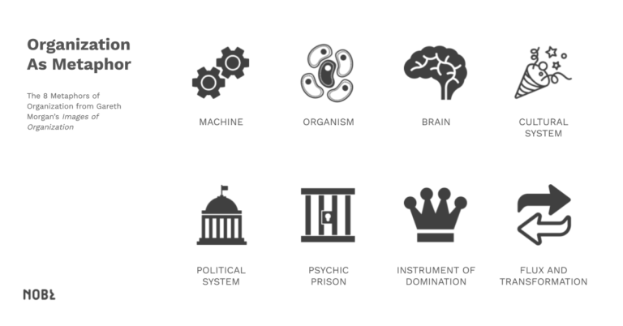

**Deshan**

## **How to Perform a SOAR Analysis**

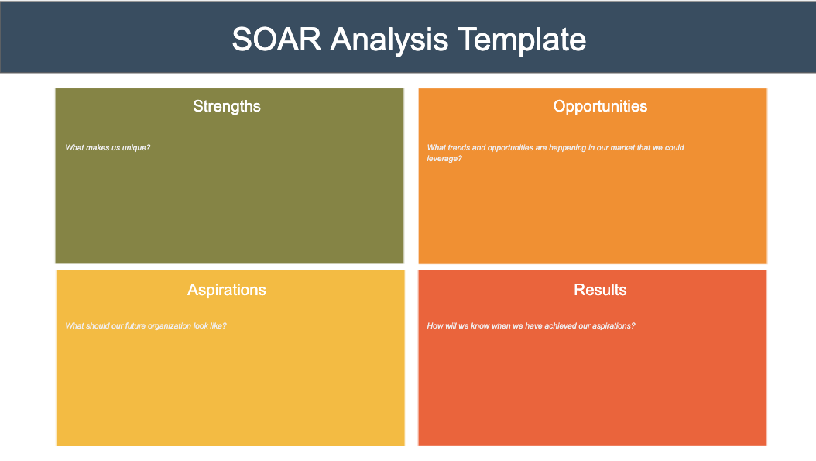

A SOAR analysis is best performed as a group exercise with key stakeholders. Use the following six-step process to help you perform your SOAR analysis.

### **Step 1: Determine objectives**

Determine why you are performing the SOAR analysis and what you hope to achieve. Determine the timeframe within which you want to achieve the results.

### **Step 2: Create a team**

Put together the team that will brainstorm ideas. Include people from all levels of the organization and important external stakeholders, if possible.

Ask each stakeholder to complete an initial questionnaire to gather their initial thoughts on strengths, opportunities, aspirations, and results. These will form a key input into the brainstorming session.

### **Step 3: Brainstorm**

Brainstorm and complete the first draft of your SOAR analysis as a team.

### **Step 4: Prune**

Prune and trim your SOAR analysis so that only the most important aspirations and results remain. Basically, you need to decide which are the most attractive opportunities you want to pursue.

Once you have done this create your compelling and challenging vision of the future and determine how you will measure success (your results).

### **Step 5: Execute**

Once your SOAR analysis is complete and approved, you need to delegate tasks to be executed. Each task identified in your SOAR analysis should have a single person ultimately responsible for it.

### **Step 6: Monitor**

You need to track progress regularly. If you don’t do this, then how will you know you are making progress towards your aspirations and the results you want to achieve.

## **Advantages and Disadvantages**

The main advantages of a SOAR analysis are:

* It doesn’t just analyse your situation but helps you set goals and targets to achieve.
* It’s forward-looking and positive, unlike SWOT, which spends 50% of its time encouraging you to fix weaknesses and threats.
* SOAR analysis is better than SWOT analysis for start-ups because the organization is so new it doesn’t know its strengths, weaknesses, or threats yet.
* It is action oriented.

The main disadvantages of a SOAR analysis are:

* Aspirations are somewhat redundant because you’ll already have this stated as your organization’s vision.
* Although it builds on your strengths, it doesn’t do an in-depth analysis of the marketplace or your customers. This could lead you to focus on the wrong thing.

n so you can bridge the gap between where you are now and where you want to be.

Source : [https://expertprogrammanagement.com/2019/11/soar-analysis/#:~:text=A%20SOAR%20analysis%20is%20an,the%20strengths%20of%20your%20organization.](https://expertprogrammanagement.com/2019/11/soar-analysis/#:~:text=A%20SOAR%20analysis%20is%20an,the%20strengths%20of%20your%20organization)

**Deshan**

# **PEST Analysis**

## **Identifying "Big Picture" Opportunities and Threats**

## *(Also known as PESTLE, PESTEL, PESTLIED, STEEPLE, SLEPT and LONGPESTLE)*

Changes in your business environment can create great opportunities for your organization – and cause significant threats.

For example, opportunities can come from new technologies that help you reach new customers, from new funding streams that allow you to invest in better equipment, and from changed government policies that open new markets.

Threats can include deregulation that exposes you to intensified competition; a shrinking market; or increases to interest rates, which can cause problems if your company is burdened by debt.

PEST Analysis is a simple and widely used tool that helps you analyse the Political, Economic, Socio-Cultural, and Technological changes in your business environment. This helps you understand the "big picture" forces of change that you're exposed to, and, from this, take advantage of the opportunities that they present.

## **Regina:**

## **SOAR vs SWOT Analysis**

From: <https://www.toolshero.com/strategy/soar-analysis/>

A SOAR analysis closely resembles a [SWOT Analysis](https://www.toolshero.com/strategy/swot-analysis/), where an internal analysis of the organisation’s strengths and weaknesses first takes place. Subsequently, the SWOT Analysis looks at external challenges and opportunities of and threats to the organisation. A SOAR Analysis, however, is more action-oriented than a SWOT and is aimed at results. SOAR is concerned with all levels and functional areas of an organisation, while SWOT usually adopts a top-down approach.

A SOAR Analysis focuses on the organisation itself and on improving what is already going well. A [SWOT Analysis](https://www.toolshero.com/strategy/swot-analysis/), on the other hand, looks at perceived threats and/or weaknesses of the organisation. Contrary to the SWOT Analysis, the SOAR model uses appreciative research to direct the company towards what is already known. As such, the output of a SOAR Analysis contains a series of actions that capitalise on the strengths and opportunities. In doing so, the organisation can strive for ambitions shared by the entire organisation: in measurable results. A SOAR offers a basis for further thorough analysis by means of other company assets. The questions below can be useful in conducting a SOAR Analysis:

* What are the organisation’s strengths?
* Which opportunities exist for the organisation?
* What does the perfect future of the organisation look like?
* Which measurable results show that the organisation’s future vision has been reached?

## **SOAR Analysis in closer detail**

Further building on an organisation’s strengths will yield better results than spending time on improving weaknesses. Every element of the SOAR Analysis is described in further detail below, with several example questions:

### **Strengths**

Within the SOAR Analysis, this concerns the most powerful strengths of an organisation. It refers to all capacities, skills and achievements (whether big or small). The following example questions apply:

* At what does the organisation excel?
* What have been the greatest achievements so far?
* What is the organisation most proud of?
* What makes the organisation unique?
* What makes the organisation valuable to purchasers?
* What does the organisation do better than its competitors?

### **Opportunities**

These are aimed at possibilities and chances the organisation has. It concerns external conditions that could improve the profit or that focus on unfulfilled needs of customers. Opportunities can also lead to a larger market share or improve the competitive advantage. Possible organisational threats or weaknesses can be reformulated into opportunities. All opportunities that emerge will eventually lead to success. Here too, example questions can be useful:

* Which collaborations could increase the chance of success?
* Which changes and market trends match with the current strengths of the organisation?
* Which threats could the organisation embrace and convert into opportunities?
* Which needs and wishes does the organisation not yet fulfil for internal stakeholders?
* Which needs and wishes does the organisation not yet fulfil for external stakeholders?
* Which gaps could the organisation fill in the market?

### **Aspirations**

Within the SOAR Analysis, these concern the ambitions an organisation has; what does the organisation aspire to be and what can it realise? Which aspirations does the organisation have for the future, what is their vision? Within this vision, an organisation would do well to build on its current strengths. With sufficient inspiration, the aspirations could be clarified, and the following example questions can be helpful:

* What does the organisation hope to achieve in the future?
* What will the future organisation look like?
* How can the organisation make a difference in the market?
* What is the organisation’s passion?
* Which strategies and actions could support the future ambitions?

### **Results**

This refers to the tangible and measurable results that indicate when the goals and aspirations have been achieved. The following example questions can be useful for this:

* Which measures ensure that the organisation is on the right track for success?
* How does the organisation translate the vision of success into tangible results?
* When does the organisation know the goals have been achieved?

**SWOT Analysis template,**

|  |  |
| --- | --- |
| **Strengths** | **Opportunities** |
| * What do we excel at / are most proud of? Group work and supporting each other. * What makes us unique? With a good mix of different culture in our group, we were able to respect and understand the pain points and cultural difficulties faced by the school. * What are our values? Be true and respectful to each other. | * What threats do we see that we could reframe as opportunities? The old buildings that can be repaired using student skills through trade classes. * What needs and wants are we currently not fulfilling? The recycling and providing the school with more laptops and iPad * What partnerships would lead to greater success? A Non-Profit agency or a donation from another school or someone that can afford to help this school by providing more Laptops, iPads. |
| **Aspirations** | **Results** |
| * What is our vision for the future, what do we want to achieve? App that would support many more things besides just helping students learn/keeping the Kaurna language alive. * How can we make a difference? By delivering a ground-breaking app idea that can be used for years to come by Students and parents. | * What measures will tell us we are on track to achieve success? Ensure we refer to our research. Read our notes and check with each other's to stay on path. * How do we know when we’ve achieved our goals? A successful pitch and if our client is happy with our idea. * How do we measure impact, change or improvement? By survey's in school and ask how students feel about the app. |

**Regina: A quote to support using Appreciative Inquiry and SOAR as our Define Tool:** a quote from the book titled *The Design of Business - Why Design Thinking is the Next Competitive Advantage* by Roger Martin: “Design thinking focuses on accelerating the pace at which knowledge advances from mystery (an unexplainable problem) to heuristic (a rule of thumb that guides us toward a solution) to algorithm (a replicable success formula).”

Hence, while appreciative inquiry embraces the world as a mystery by not dwelling on problems, design thinking is not averse to the mystery even if it is an unsolved problem (read nightmares, [wicked problems](http://en.wikipedia.org/wiki/Wicked_problem) etc.). It aims to find creative ideas to overcome problems and exploit opportunities. It holds design as a purposive application of creativity throughout the process of innovation (where innovation involves the successful application of new ideas in the form of improved products, processes and services). Thus, design, like appreciative inquiry, aims to see the world as it could be, and not as it is.

**Bottom line:** Organizations need to exploit the transformative power of design thinking through appreciative inquiry.

Taken from: <https://ksahu.blogspot.com/2012/05/design-thinking-and-appreciative_24.html>

**Regina:**

Here is a different way of exploring a client’s context:

The ‘Father’ of Appreciative Inquiry, David Cooperrider: <https://www.davidcooperrider.com/ai-process/> Appreciative Inquiry and the corresponding tool SOAR are based on the foundations of Positive Psychology. Where the SWOT analysis tool is viewed by some to be a ‘top down, negative, deficit approach’ to looking at an organization, SOAR is seen to be a more ‘whole system, positive, active’ approach to instigating change in an organization.

**SUCCESSES AND OPPORTUNITIES IDENTIFIED FROM THE CLIENT INTERVIEW/ VIDEO:**

**Added by Regina:**

* **Kaurna language taught to Aboriginal students in Years 3-7**
* **SACE Completion is high**
* **The SAASTA program that can begin in Year 9, but is mainly for Year 11 and 12 Aboriginal students**

**Regina:** I’ve added a table where we can show how we used each of the techniques used in analysing the client interview:

|  |  |  |  |
| --- | --- | --- | --- |
| **Tool** | **Applied to client analysis** | **Reason/s why will be used** | **Reason/s why won’t be used** |
| SWOT | **Regina: (here is what I have identified from the client interview, *so far*)**  **Strengths:**  **SACE completion.**  **Tirkanthi offers support to all Aboriginal students, no matter their backgrounds.**  **Well-being support is provided to students to support them in their lives, their studies and their goals.**  **Kaurna language taught from Years 3-7.**  **SAATSA beginning from Year 9, but more focussed on Years 11 and 12 (Stage I and Stage II) senior students is offered to support Aboriginal students in completing their SACE, offering a wide range of subjects, including culture, sport and VET courses.**  **VET courses are offered to students, which not only provides them with SACE points, but also gives them a certification that can lead to possible employment, or entry into university or TAFE courses.**  **Students who are resilient and able to overcome**  **Weaknesses:**  **Behavioural problems that are not necessarily dealt with in a way that helps students to change their negative behaviour patterns to more positive ones.**  **Kaurna language only offered to Years 3-7.**  **Kaurna language is currently being taught by a non-native speaker who has limited skills.**  **SAASTA is only offered to senior school students and there is no comparable program offered to primary students or middle-school students.**  **ICT devices, such as iPads and laptops are limited and need to be booked by teachers to use in class. Sometimes there are not enough devices available for all students.**  **The time that it takes to repair devices when they need it is often quite long.**  **Administrative tasks that are time consuming, such as applications for funding.**  **Too many systems in use that do not always provide ease of use, such as EDSAS and DayMap.**  **Inconsistencies in communication to parents and the way communication is conducted.**  **Bullying, through the use of social media sites like SnapChat.**  **Not enough ICT people to help solve ICT problems when they arise and fix them quickly, or to provide ICT support as needed.**  **Everything has to be budgeted for, with budgets for any projects, staff, ICT purchases, building repairs etc having to be submitted by August of the year before the beginning of the next school year in January.**  **All funding has to be justified, staffing budgets, resource budgets, etc.**  **Opportunities:**  **Finding a better way for punishing bad behaviour. (Instead of not letting them come to school).**  **Providing Kaurna language to all Year levels and all students, not just Aboriginal students.**  **Providing a program for primary school and/or middle-school students that provides the same opportunities as SAASTA does for senior school students and provides a streamlined segue from primary school to middle-school to the senior school program.**  **A good system to manage and track data, and result students in a consistent way that can be used to support students.**  **Threats:**  **Lack of funding to provide needed support to students.**  **Lack of funding to provide more innovative programs for students.**  **Lack of funding to purchase and maintain devices for all students.**  **Lack of support for students in need.**  **The school being at over-capacity.**  **Old buildings being in need of repair and inadequate for the needs of the school.**  **Lack of available devices for use by all students.**  **Bureaucratic constraints that are hard to overcome or get around due to having to meet the Department of Education requirements, such as the Department of Education’s approach to dealing with students with problem behaviour or the way student support is allocated or how money is allocated to the school.**  **Having to use the Department of Education network, which can be slow, unstable and unreliable.** | **Regina:** SWOT can provide a clear picture of the client’s situation by showing the external and internal areas that could be a focus for improvement. While SWOT is often seen as being a negative approach to organisation change/ improvement, there are advantages in using SWOT as a tool to identify the organisations change/ pain points in that it provides a clear and simple to use tool that can be added to at every step of the analysis of the client’s context. | Angela: We have SOAR a more positive approach to swot.  (We still need to check as a team if we want to use SWOT or SOAR) |
| PEST | **Political:**  **Economic: Covid (Social distancing)**  **Social:**  **Technological:** | **Harp:** Let’s use PEST too as COVID played a part in economy and More use of TECH by students at home. |  |
| Porter’s 5 Forces | **Buyer Power:**  **Threat of Substitution:**  **Supplier Power:**  **Threat of New Entrants:**  **Competitive Rivalry:** |  | **Regina**: I’m not sure that this tool will be helpful in assessing the client’s needs, as Tirkanthi is not really in competition with any other similar organisation. Nor does the public education system operate like a company such as IBM, the example given in our tutorial! What do the rest of the team think? |
| Blue Ocean | **Eliminate:** Recycling/waste  **Raise:** Awareness with parents and keep in touch more often.  **Reduce:** Amount of paperwork needed to get funding  **Create:** Better computer labs/classrooms. |  | AS Kirsten mentioned in her comment. I have added Blue Ocean to our strategy as there were pain points that are relevant to this analysis. |
| Morgan’s Metaphors | **Machine:**  **Organism:**  **Brain:**  **Culture:** This metaphor should be used as School has Aboriginal student. As mentioned in the interview we shouldn’t use the term ‘indigenous.’ These are the type of cultural things we need to be aware of.  **Manifestation of Power:**  **Psychic Prison:**  **Change and Flux:**  **Instrument of Domination:** |  | Angela: As a team we decided this would not be helpful as the metaphors have cultural undertones that will not translate to those not in the culture. Having a diverse team we don’t find this helpful as not all of us understand these metaphors; as well as the client! |
| Rich Pictures | **Strengths:** It may help us to consider the things from another perspectives.  **Weakness:** It is unorganized. It does not clearly state what we meant. | Kaan: This technique can be a good source to express our subconsciousness more freely, and it may bring up many hidden parts of the project. | Kaan: It does not look professional and it is not organized. It may confuse the reader. |
| SOAR | **Regina:**  **Strengths:**  **Tirkanthi offers support to all Aboriginal students, no matter their backgrounds.**  **Well-being support is provided to students to support them in their lives, their studies and their goals.**  **SACE completion is high.**  **Opportunities:**  **Aspirations:**  **Results:** | Angela: This will be a tool best suited to find the specific positive aspect of the client's issues and through this we can really analyse and find the strengths.  I would recommend using this only after you use pest or have found the specific problem.  **ROJINA**:  I think SOAR analysis is a one of the best and powerful tool to bring stakeholders together to recognize the potential of the organization and create a shared vision of the future. In SOAR building on strengths requires less effort and resources than trying to correct weaknesses. This technique is more action oriented than a [SWOT analysis](http://www.groupmap.com/map-templates/swot-analysis/) and is focussed on outcomes. |  |

Now that we have interviewed the client, we need to go through the video, analyse the information and present the ‘problems and issues’ as identified by the client that will form the focus of our design. Below is a way that we can do this, from the IDEO Field Guide to Human-Centred Design, page 31. It is suggested that we do this a number of times, until we think it is doable.

**Rojina**

**STAGE 1: Empathy**

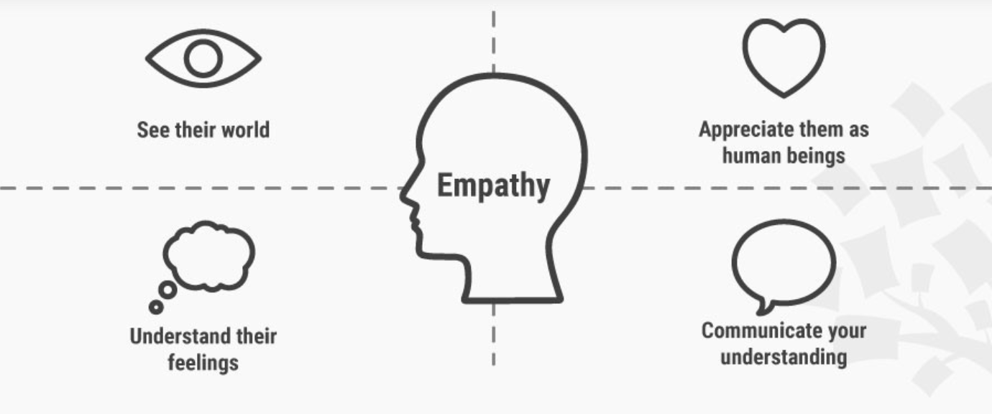

Design Thinking cannot begin without a deeper understanding of the people you are designing for. In order to gain those insights, it is important for you as a design thinker to empathize with the people you’re designing for so that you can understand their needs, thoughts, emotions and motivations. The good news is that you have a wide range of methods at your command for learning more about people. The even better news is this: with enough mindfulness and experience, anyone can become a master at empathizing with people.

"Engaging with people directly reveals a tremendous amount about the way they think and the values they hold. Sometimes these thoughts and values are not obvious to the people who hold them. A deep engagement can surprise both the designer and the designee by the unanticipated insights that are different from what they actually do - are strong indicators of their deeply held beliefs about the way the world is."

There are three types of empathy . They are:

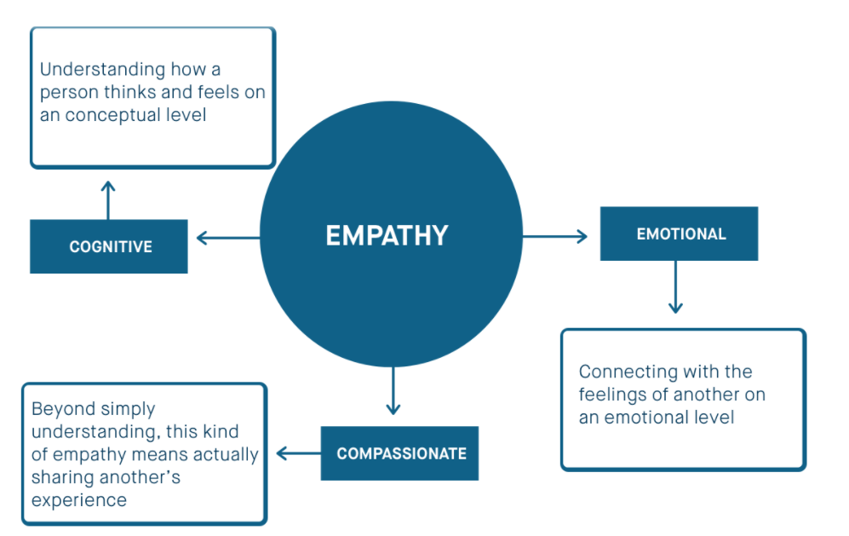

**Preparing for Interview with the Client:**

**Regina:** Here’s some suggestions from the IDEO Field Guide to Human-Centred Design on interviewing the client. Here’s the reason why interviews are considered an important part of human-centred design: “Interviews really are the crux of the Inspiration phase. Human-centered design is about getting to the people you’re designing for and hearing from them in their own words. Interviews can be a bit daunting, but by following these steps below you’ll unlock all kinds of insights and understanding that you’ll never get sitting behind your desk. Whenever possible, conduct your interviews in the interviewee’s space. You can learn so much about a person’s mindset, behaviour, and lifestyle by talking with them where they live or work.” (taken from the IDEO website)

Though we will have to ignore the first one, where it states that only three team members should attend any single interview, we should designate each member with a role. I also like the idea of having at least two of us taking notes. Though, we will need to ask permission from the client if this is appropriate.

**Design Thinking Task**

**Empathy**

|  |  |
| --- | --- |
| **EMPATHY** | **MAP** |
| **SAID**   * Less ICT facilities in both school and home * Lack of funding to school * Condition of the buildings are not that good * Inter-generational trauma * Kaurna language is in danger | **THOUGHT**   * Intention to protect the Culture, Language and community * Only government support is not adequate * Need extra care on students with learning disabilities and behavioural issues * Measures need to take to protect the complete language |
| **ACTED**   * Measures taking to help the students within the school * Students that are misbehaving are being “rewarded” for bad behaviour through suspension * Informing the public to get more support * Programs to recover students from drugs | **FELT**   * Frustration at administrative tasks * Amazed at the resilience of the students * Feel bad on drug addicted students and their future * Risk of extinction of the community |

**Harp -**

Hi Team,

Just thought to do a bit of background on our client - Tirkanthi group at Paralowie R-12 School.

Tirkanthi is a Kaurna word which means ‘a learning place’. 160 Aboriginal students attend this school. All Aboriginal students at the school receive academic and wellbeing support from the education team. Students can even learn a certificate III in Aboriginal Languages.

School provides support for Culture, wellbeing, Academic. Financial and system support. School has South Australian Aboriginal Secondary Training Academy (SAASTA) which gives all aboriginal students the option to be a part of program to receive SACE (South Australian Certificate of Education), join the sports teams and understanding Aboriginal culture.

Tom Putnam is the Aboriginal Education Coordinator.

My Question for the panel-

* What role can your education system play in supporting that vision for young Aboriginal students?
* How are you closing the gap that exists between aboriginal and non-aboriginal students in the real world?

**Persona: BY Harp**

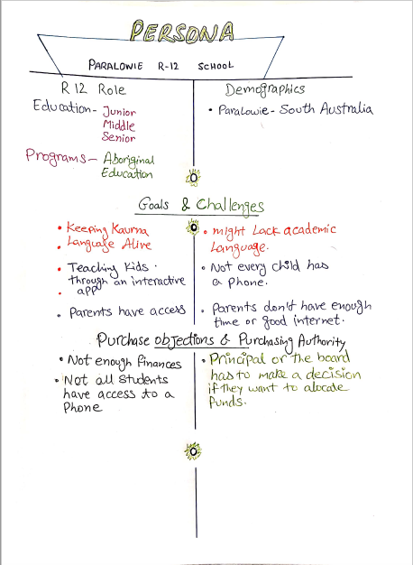

**Journey Map: By Rojina Sharma**

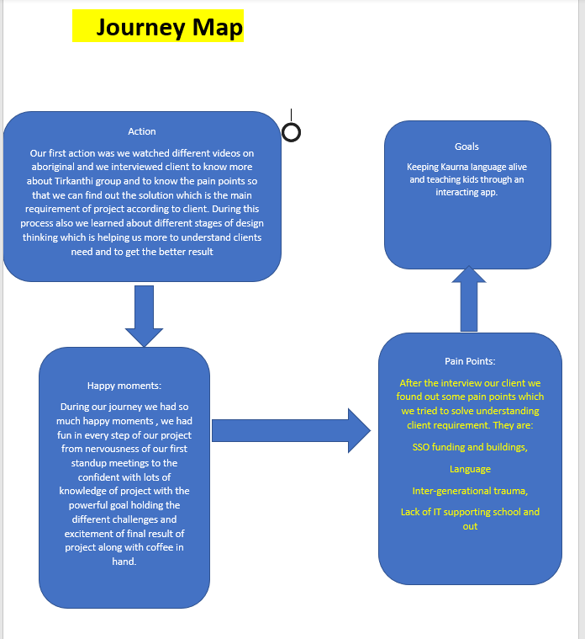

**Pain Points of the Client**

**Angela :**

**What is a pain point?**

(If anyone in the team have identified any pain points place them in this section – much love, Angela)

A pain point as it suggests is a flaw in which the client is aware need to **b**e fixed and for you to provide a solution.

**How to address a pain point?**

* **Financial**
* **Productivity**
* **Process**
* **Support**

Viewing customer pain points in these categories allows you to start thinking about how to position your company or product as a solution to your prospects’ problems, and [what is needed to keep them happy](https://www.wordstream.com/blog/ws/2020/04/14/goal-talk-episode-10). For example, if your prospects’ pain points are primarily financial, you could highlight the features of your product within the context of a lower monthly subscription plan, or emphasize [the increased ROI your satisfied customers experience](https://www.wordstream.com/blog/ws/2016/10/04/adwords-roi) after becoming a client.

<https://www.wordstream.com/blog/ws/2018/02/28/pain-points>

Angela - Pain points I have found in the client discussion panel includes the following:

(Will be posting tomorrow after watching video)

* The client is only getting enough funding to help students with learning disabilities or behavioural issues for an hour.
* Students that are misbehaving are being “rewarded” for bad behaviour through suspension.
* The client is

Harp -

Structure - Building and structure. They are very old and require repairs. Building has asbestos. These weren’t designed for environmental principals. Funding is another factor; School allocates money but doesn’t have enough from the government funding etc. Needs additional resources for recycling and disposing of materials etc. They can’t prioritise recycling without taking focus from another challenges school has.

Funding- Student don’t get enough funding required to provide extra layers of support. Some students are left behind from early stages where they too far behind. Too many funding applications where it takes way too long. A student that needs full time support is only given one hour of support

An- Communication with parents

Rojina- Pain point solved, Recycling and suspension

Deshan- Lack of IT support in school and out.

**Kaan-**

* Most of the students experience inter-generational trauma (Inter-generational trauma is a traumatic event that began years prior to the current generation and has impacted the ways in which individuals within a family understand, cope with, and heal from trauma).
* Several students have drug or alcohol addiction problems.
* Spending too much time when it comes to timetable the things. There needs to be a way to facilitate it.
* The funding process needs to be streamlined. - Too much paperwork.

Regina:

* The buildings are old and in need of repair/ replacement
* There is not enough money/ funding to do all the projects that they would like to do to support the students
* Funding is not always available for projects that they would like to do

**Analysis**

Rojina:

Pain point solved, Recycling and suspension

Solution: having students who are misbehaving do “community work” as a productive punishment to contribute to helping with recycling.

Fatih Kaan:

Pain Point: Inter-generational trauma

Solution: Group therapy (after school), motivational speakers/ elders who have overcome the same problem.

Deshan:

Pain point: Lack of IT support in school and out.

Solution: Approach other schools to share their unused IT infrastructure, the students from the other schools or teachers do a workshop on how to use the tools.

Angela:

Pain Points solved: Language

Solution: To keep the Kaurna language alive, develop an app that can be used by students after the school

Harp:

SSO Funding

Solution: To have Volunteer teacher or student teachers provide extra help.

Building –

Solution: Teach students' skills set to do minor repairs on old building, painting, landscaping etc.

**An**:

Pain Point: Communication with parents

Solution: Make a website for the school so that parents can see their child's progress.

**Rojina: DEFINE**

**Stage 2 in the Design Thinking Process: Define the Problem and Interpret the Results**

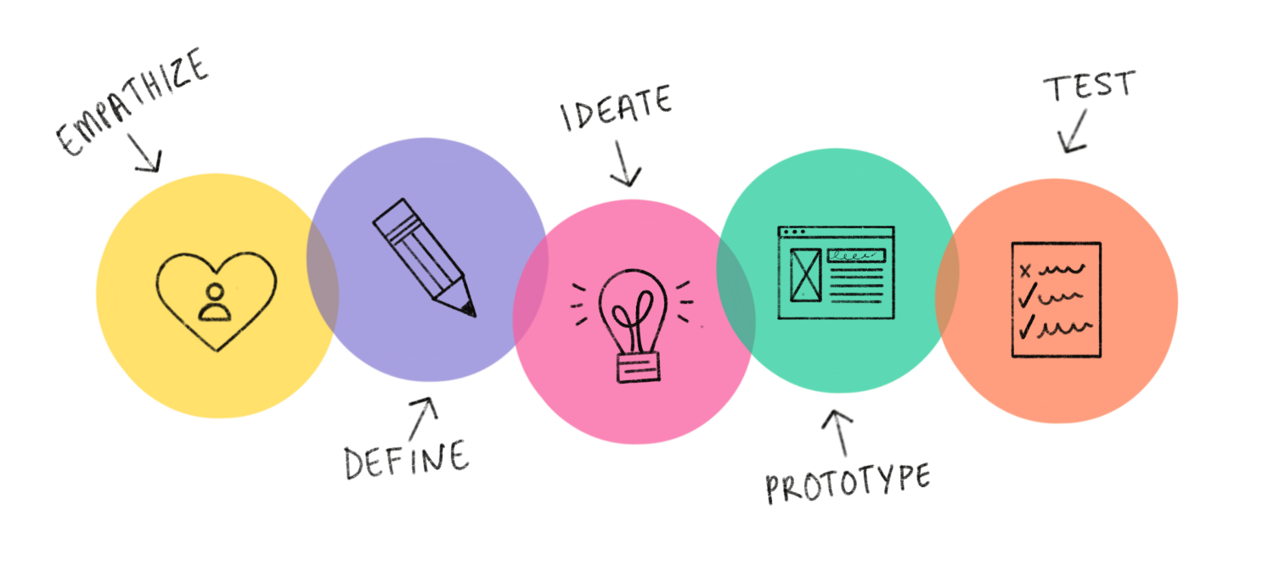

The second stage in a typical Design Thinking process is called the Define phase. It involves collating data from the observation stage.

In the Define stage you synthesise your observations about your users from the first stage, the Empathise stage. A great definition of your problem statement will guide you and your team’s work and kick start the ideation process (third stage) in the right direction. The five stages are not always sequential — they do not have to follow any specific order and they can often occur in parallel and be repeated iteratively. As such, the stages should be understood as different modes that contribute to a project, rather than sequential steps.

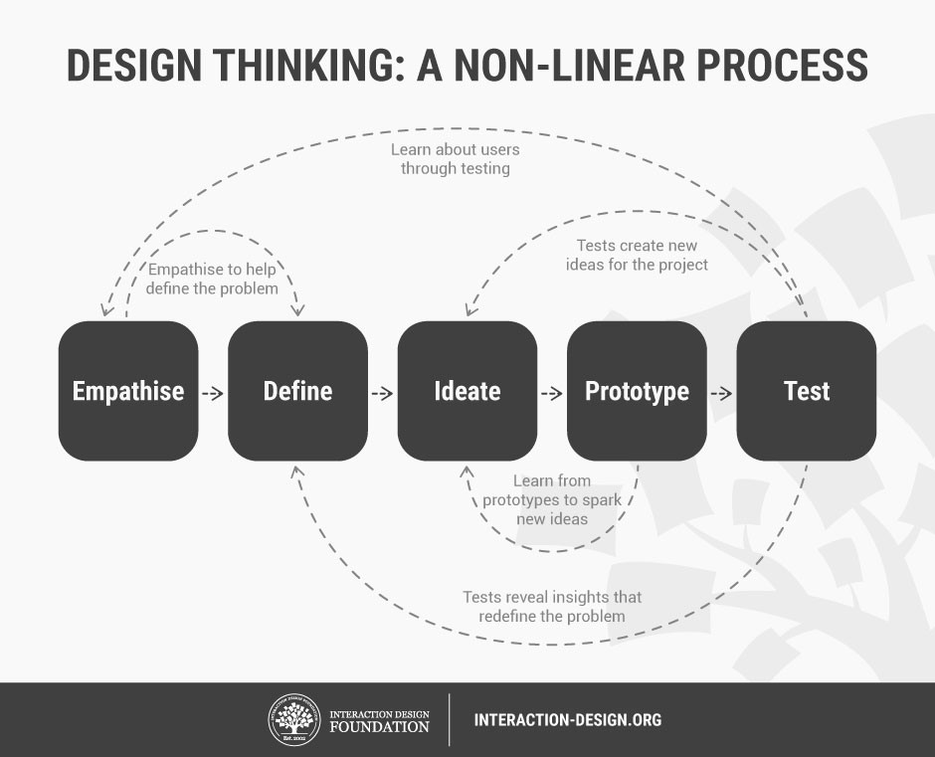

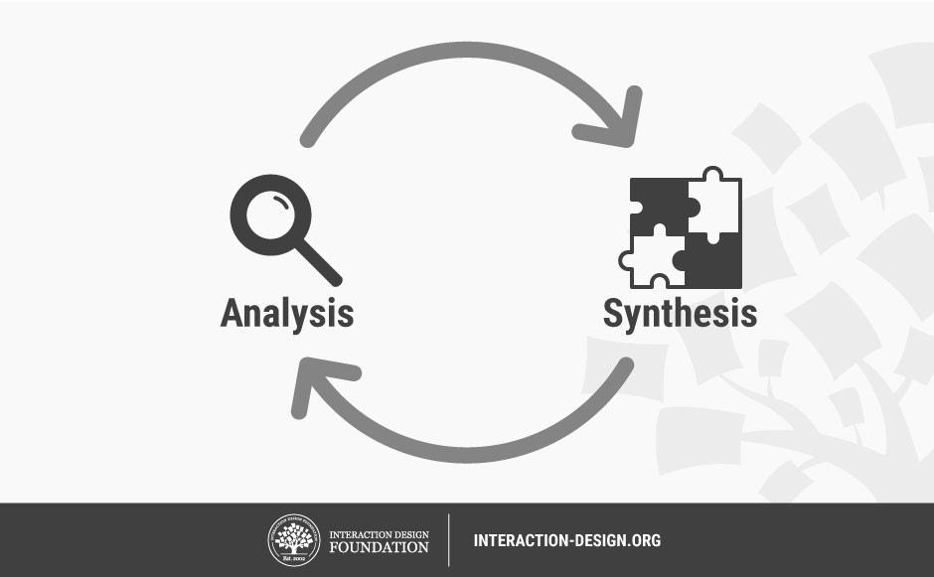

Before we go into what makes a great problem statement, it’s useful to first gain an understanding of the relationship between analysis and synthesis that many design thinkers will go through in their projects. Tim Brown, CEO of the international design consultancy firm IDEO, wrote in his book Change by Design: How Design Thinking Transforms Organizations and Inspires Innovation, that analysis and synthesis are “equally important, and each plays an essential role in the process of creating options and making choices.”

**Analysis** is about breaking down complex concepts and problems into smaller, easier-to-understand constituents. We do that, for instance, during the first stage of the Design Thinking process, the Empathise stage, when we observe and document details that relate to our users.

**Synthesis,** on the other hand, involves creatively piecing the puzzle together to form whole ideas. This happens during the Define stage when we organise, interpret, and make sense of the data we have gathered to create a problem statement.

According to my understanding

A problem statement identifies the gap between the problem and the desired state the goal of a process or product.

Within the design context, we can think of the user problem as an unmet need. By designing a solution that meets this need, where we can satisfy the user and ensure a pleasant user experience.

Problem statements can take various formats, but the end goal is always the same: to guide the design team towards a feasible solution. Let’s look at some of the ways you might frame your design problem:

* **From the user’s perspective:** “I am a young working professional trying to eat healthily, but I’m struggling because I work long hours and don’t always have time to go grocery shopping and prepare my meals. This makes me feel frustrated and bad about myself.”
* **From a user research perspective:** “Busy working professionals need an easy, time-efficient way to eat healthily because they often work long hours and don’t have time to shop and meal prep.”
* **Based on the four W’s—who, what, where, and why:** “Our young working professional struggles to eat healthily during the week because she is working long hours. Our solution should deliver a quick and easy way for her to procure ingredients and prepare healthy meals that she can take to work.”

#### What makes a good problem statement?

A good problem statement is human-centred and user-focused. Based on the insights you gathered in the empathize phase, it focuses on the users and their needs—not on product specifications or business outcomes. Here are some pointers that will help you create a meaningful problem statement:

* **Focus on the user:** The user and their needs should be front and centre of your problem statement. Avoid statements that start with “we need to…” or “the product should”, instead concentrating on the user’s perspective: “Young working professionals need…”, as in the examples above.
* **Keep it broad:** A good problem statement leaves room for innovation and creative freedom. It’s important to keep it broad enough to invite a range of different ideas; avoid any references to specific solutions or technical requirements, for example.
* **Make it manageable:** At the same time, your problem statement should guide you and provide direction. If it’s too broad in terms of the user’s needs and goals, you’ll struggle to home in on a suitable solution. So, don’t try to address too many user’s needs in one problem statement; prioritize and frame your problem accordingly.

**Developing a Problem Statement**

**Harp:**

**What is a problem Statement?**

A problem statement is a clear and concise sentence that seeks to explain the specific problem that needs to be solved.

Key to solving problems is by asking the right questions in the first place and early on. The more clarity a team has on what the problem is they will be more efficient in coming up with ideas to solve the problem.

I think this is the point of this subject – making us good at identifying problems early and asking the right questions.

A template I found on Problem Statements:

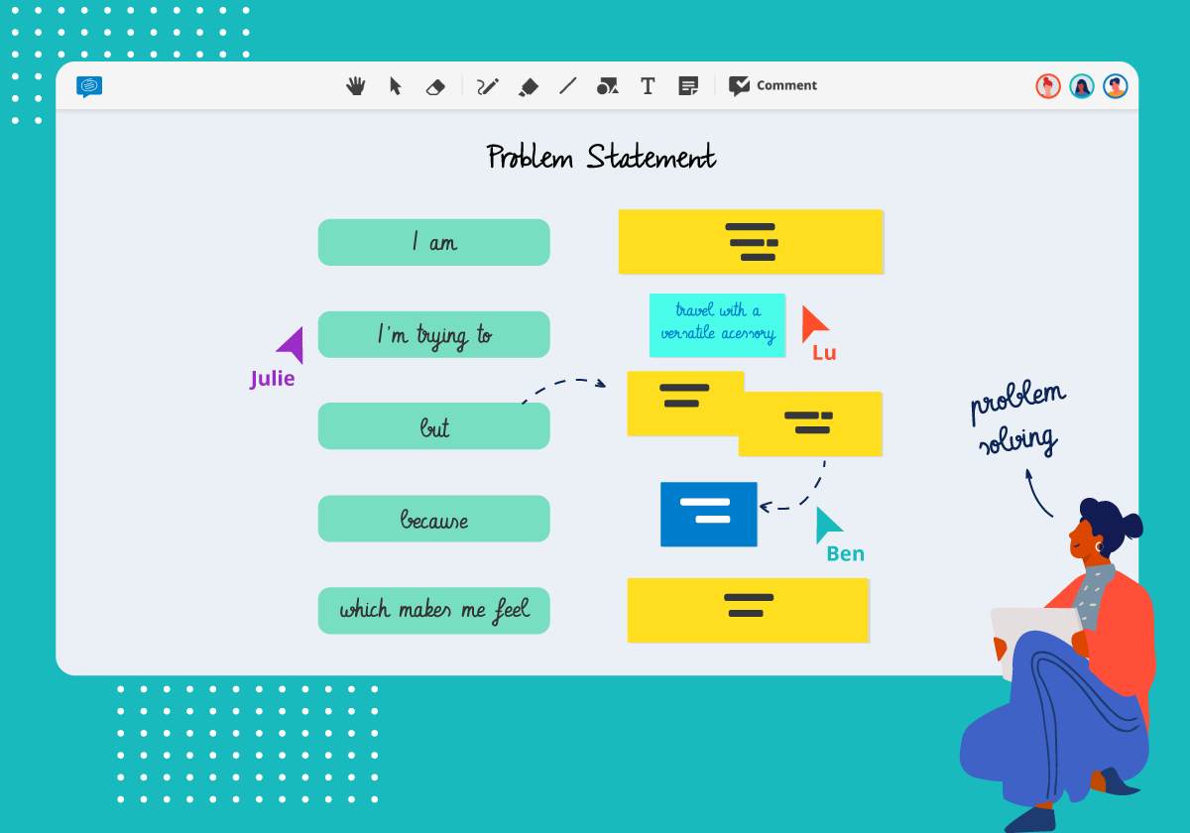

-Written by Kaan, but the whole team contributed

**STAGE 2 – DEFINING THE IDEA OUR TEAM HAS**

(The idea we have is to make a language app where Kaurna language will be immortalized.)

**Analysis:**

They need teachers who can teach Kaurna language. They had two teachers teaching the language, however they left for some reasons. Right now, Tom is teaching the language; however, his timetable is overloaded, so he needs help in relation to the language. Another problem is that there are local people who can teach the language, yet they do not have the qualifications. All in all, they need qualified teachers to teach the language, so that’s why they have concerns regarding keeping the language alive.

**Synthesis:**

In this stage we are putting the pieces together. As a team we came up with the idea of having a language app in which there will be interactive interfaces teaching students the Kaurna language. Thus, eliminating the concerns of the client. The information regarding the content of the app will be given in latter stages.

**Problem Statement:**

**How do we keep the language alive while finding the qualified teachers to teach it?**

Harp- This is what we have reached a goal of developing an App that will keep the language alive and be easily accessible to student and even parents. This way school don’t have to hire a teacher that can teach the language. This way Schol will save money too and use it other problems that were mentioned in the Video by Tom.

-KAAN

# **Stage 3 in the Design Thinking Process:**

# **Ideate**

In the Ideation stage, design thinkers spark off ideas — in the form of questions and solutions — through creative and curious activities such as Brainstorms and Worst Possible Idea. In this article, we’ll introduce you to some of the best Ideation methods and guidelines that help facilitate successful Ideation sessions and encourage active participation from members.

When facilitated in a successful way, Ideation is an exciting process. The goal is to generate many ideas — ideas that potentially inspire newer, better ideas — that the team can then cut down into the best, most practical and innovative ones.

“Ideation is the mode of the design process in which you concentrate on idea generation. Mentally it represents a process of “going wide” in terms of concepts and outcomes. Ideation provides both the fuel and the source material for building prototypes and getting innovative solutions into the hands of your users.”

The main aim of the Ideation stage is to use creativity and innovation in order to develop solutions. By expanding the solution space, the design team will be able to look beyond the usual methods of solving problems in order to find better, more elegant, and satisfying solutions to problems that affect a user's experience of a product.

## **Ideation Will Help You:**

* Ask the right questions and innovate.
* Step beyond the obvious solutions and therefore increase the innovation potential of your solution.
* Bring together perspectives and strengths of team members.
* Uncover unexpected areas of innovation.
* Create volume and variety in your innovation options.
* Get obvious solutions out of your heads and drive your team beyond them.

## **Ideation Methods to Spark Innovative Ideas**

There are hundreds of ideation methods. Some methods are merely renamed or slightly adapted versions of more foundational techniques. Here you’ll get brief overview of some of the best methods:

* Brainstorm
* Braindump
* Brainwrite
* Brainwalk
* Challenge Assumptions
* SCAMPER
* Mindmap
* Sketch or Sketchstorm
* Storyboard
* Analogies
* Provocation
* Movement
* Bodystorm
* Gamestorming
* Cheatstorm
* Crowdstorm
* Co-Creation Workshops
* Prototype
* Creative Pause

## **Ideation Methods to Select Ideas**

Once the Ideation session is complete, the ideas must be collected, categorised, refined and narrowed down, so the team is able to select the best solutions, ideas, and strategies from a shortlist. These methods can help you select the best idea at the end of an Ideation session:

* Post-it Voting or Dot Voting.
* Four Categories Method
* Bingo Selection
* Idea Affinity Maps
* Now Wow How Matrix
* Six Thinking Hats
* Lean Startup Machine Idea Validation Board
* Idea Selection Criteria

In the following section, we’ll provide you with a brief introduction to some of the best methods.

### **Post-it Voting or Dot Voting**



In post-it voting, all members are given a number of votes (three to four should do) in order to choose their favorite ideas. Ideas that are generated in the Ideation sessions are written down on individual post-its, and members can vote by using stickers or a marker to make a dot on the post-it note corresponding to the ideas they like. This process allows every member to have an equal say in choosing from the shortlisted ideas.

### **Four Categories Method**

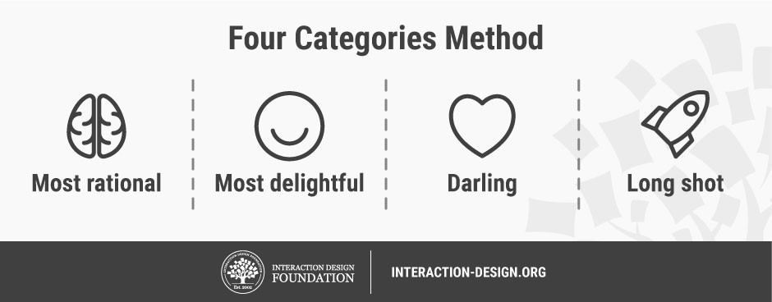Author/Copyright holder: Teo Yu Siang and Interaction Design Foundation. Copyright terms and licence: CC BY-NC-SA 3.0

The [four categories method](https://www.interaction-design.org/literature/topics/four-categories-method) involves dividing ideas according to their relative abstractness, ranging from the most rational choice to the 'long shot' choice. The four categories are: the rational choice, the most likely to delight, the darling, and the long shot. Members then decide upon one or two ideas for each of these categories. This method ensures that the team covers all grounds, from most the practical to those ideas with the most potential to deliver innovative solutions.

### **Bingo Selection**

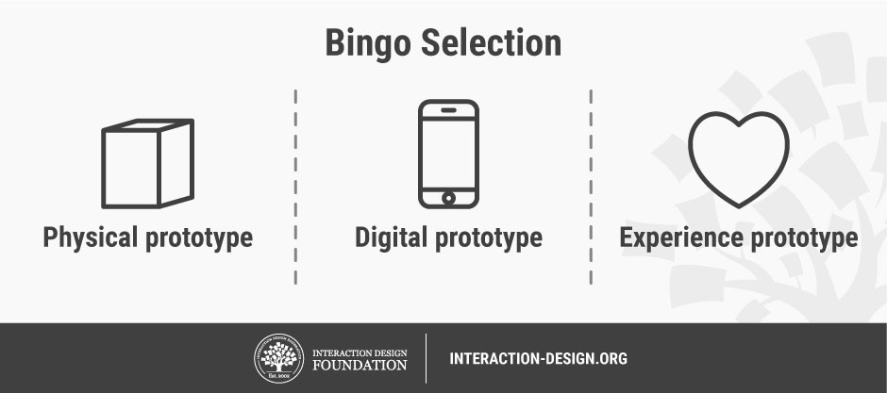

Similarly, the [Bingo selection](https://www.interaction-design.org/literature/topics/bingo-selection) method inspires members to divide ideas. However, in this method, contributors are encouraged to split ideas according to a variety of form factors, such as their potential application in a physical prototype, a digital prototype, and an experience prototype.

## **The Takeaway**

Ideation is often the most exciting stage in a Design Thinking project because almost unrestrained free thinking can occur within the given field. In the Ideation stage, the aim is to generate a large quantity of ideas — ideas that potentially inspire newer, better ideas — which the team can then filter and narrow down into the best, most practical, or most innovative ones. There are many great methods that can help the design team during the Ideation sessions.

-Kaan and the team

TEAM’S IDEATE STAGE PROCESS:

In order to get some innovative ideas, we used some of the methods listed above.

Mainly we used Brainstorming, Sketch and SCAMPER methods.

First, we used Brainstorming and Sketch to have many ideas before narrowing them down.

Some of them were:

* Creating a blog in the school’s website,
* Asking for help from their community to help the students after school hours,
* Recruiting the teachers to teach the language,
* Just using one room which would be designed with different sorts of materials in relation to the language,
* Creating a YouTube channel,
* Creating a website to learn the language,
* Creating a language application like Duolingo or Babbel,
* It should not just be language. We should do it together with the history and culture parts in it,
* In the app, we should also make a blog where we will be touching upon the recycling issues,
* There would be too much to cover. We should just stick to language part,
* There should be a grading function in the app so that the workload of teachers will be alleviated,
* But there will be a set of problems in terms of the academic side of the language,
* Instead of language app, we can prepare paper works for each year to be used,
* Community members can be invited to the classes,
* Rather than language app we can just stick to the recycling issue,
* There is another issue called inter-generational trauma, we can do something about it,
* A number of psychologists can be invited,
* Rather than addressing the issue of the students, for parents we can arrange some seminars or sessions with psychologists.
* Also there is another issue of communications between the parents and families. To solve this, we can create a call line,
* Maybe we can create a kind of application where the parents will convey their messages,

At this point, we used SCAMPER to organize the ideas and to narrow them down a bit. We were more inclined on making an app to address the issue or issues.

**SCAMPER -**

Substitute

**How can I substitute the place, time, materials or people?**

* With an app we can substitute them all. In a way, we can make the language immortalized.

**Can I substitute one part for another or change any parts?**

* Rather than having multiple parts, we can make it for a specific purpose and make it more efficient.
* Otherwise, to strive for covering all the issues at once, each part may not be as efficient as we want.

Combine

**What ideas, materials, features, processes, people, products, or components can I combine?**

* We can add grading feature to the app. We can design the exercises in relation to the history and culture of the community.

**What can I combine in order to lower the costs of production?**

* We can get the people from community to make the content, we could use some funding for this.

Adapt

**Does the history offer any solutions?**

* Yes, it may facilitate the learning like what language family it belongs to or the things in the culture contributed the language.

**What processes should I adapt?**

* Communication process with the community is crucial. Also, testing holds great important. We need to get feedbacks from the people who speak the language fluently.

Modify

**Can I add extra features?**

* We can add listening part as well or a part about the history of the language.

Put to Another Use

**How would people with different disabilities use it?**

* There should be listening, writing, speaking and reading parts altogether.

Eliminate

**Can I reduce effort?**

* There are ready templates that we can use. Also, there are heaps of language teaching apps, so we can have a look at them and get some ideas.

**AFTER THIS PART, IT WAS TIME FOR SELECTING THE IDEA (PRETTY MUCH IT WAS CLEAR TO US WHAT TO CHOOSE AFTER ALL WE USED THE METHOD CALLED POST-IT VOTING or DOT VOTING:**

We selected make an app just to specific to the language problem. There won’t be any other section where we will cover other issues. That way, we will make the app to the point and as much efficient as we can. There will be reading, listening, speaking and writing sections. Also, there will be an exams section to be graded.

All in all, even if there is not anyone left to speak or teach the language, there will be an opportunity to revive the language.

**Potential Biases and Assumptions that we may have about our client:**

**Regina:** <https://www.betterevaluation.org/en/blog/confusing_empathy_with_bias>

* They have plenty of government funding
* They are not willing to interact with the people from other backgrounds.
* They might have biases towards us that we may be just doing things because it is asked from us, and we do not really care about them. (we should be more genuine about what we are doing)
* All students will take up sports and do better than non-aboriginal students because there are special program and extra help provided.

Angela

* There students are hard to work with.
* They do not speak English
* They will not be satisfied with the work provided for.
* They get more support as a school.

**Harp:** - https://www.diversityaustralia.com.au/unconscious-bias/

Article about unconscious bias.

**Deshan**

# **Stage 4 in the Design Thinking Process:**

# **Prototype**

**Design Thinking Task - Prototype**

As we all learnt in our class prototyping is the initial stage of visualising what we have planned to implement. This is the first time we see a model of our final product. This model takes you less cost and is very effective to identify any problems which could arise in the final product. Designers get a chance to make it happen and see how the clients would react on the model of the product they expect.

Prototypes are used to determine whether the final users are satisfied with a sample of the final product for the solution they have requested from the designers. Also prototyping helps the designers to find solutions for the problems of the final design before they prepare the real final product which is very important because if we can solve all the problems in the prototyping stage it could avoid any unnecessary cost that could occur due to issues with the final product and could avoid any bad reputation among final users.

How the users interact with the product is one of the best ways for designers to find solutions for clients’ problems. As I said earlier creating a finished product just for the testing is costly and is not a good idea before the final production. If something is wrong or fail in the model product designers could change their plans and will cost the project very cheaply.

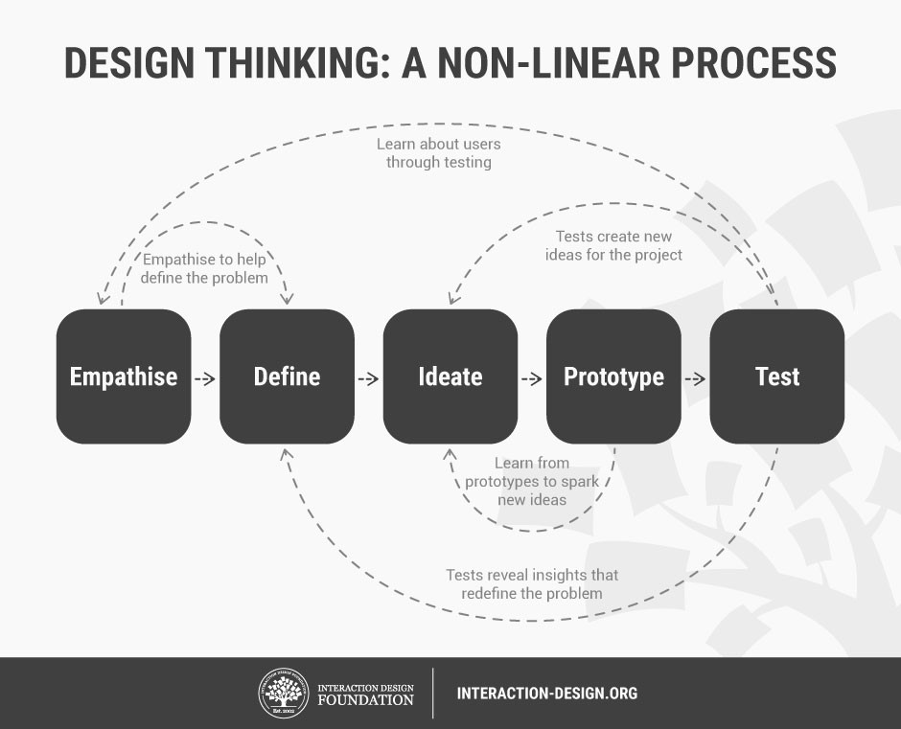

Image source - https://www.interaction-design.org/literature/article/stage-4-in-the-design-thinking-process-prototype#:~:text=One%20of%20the%20best%20ways,problems%20with%20the%20current%20design.

“They slow us down to speed us up. By taking the time to prototype our ideas, we avoid costly mistakes such as becoming too complex too early and sticking with a weak idea for too long.”  
– Tim Brown

**PROTOTYPE**

A link to Google’s page on using colour in paper prototyping: [Google: Colour usage and palettes.](https://material.io/design/color/the-color-system.html#color-usage-and-palettes)

Another link, this one about design: [Design](https://material.io/design)

**Some hints for paper prototyping:**

## Draw one sketch per screen

It might be tempting to save space and create a few states of a page/view on the same piece of paper. But it’s better to avoid that temptation. It will be much harder for people to test such prototypes — when you have too many things to show on the sketches, it becomes too cluttered, and test participants will have a hard time trying to understand which group of elements belong to one section.

## Prototype for the smaller screen first

If your product will be available for mobile and desktop users, it’s recommended to prototype mobile-first. Because of the limited screen space, you’ll be forced to prioritize content. When you optimize content for mobile, it’ll be much easier to scale up your experience for other viewports.

## Use colours intentionally

Draw up your prototype in black and white. Use colours intentionally — to highlight a specific element (such as buttons).

Also, as soon as you choose the colours you want to use, try to maintain consistency throughout the paper prototype. For example, all interactive elements should be coloured in the same colour (e.g. blue is used only for interactive elements). It will help you to reduce cognitive load during usability testing.

## Create a digital copy of your prototype

Create a digital copy of your prototype will help you to avoid carrying a pile of paper from meeting to meeting. All you need to do is to take a series of shots using your phone.

**Tip:** You can also create an animated GIF with a specific user flow. Simply take photos of sketches that represent a particular flow and create a GIF out of them.

## Create a digital prototype out of a paper prototype

It’s also possible to use paper sketches as a basis for a low-fidelity digital prototype. There’s an excellent tool called [POP by Marvel](https://marvelapp.com/pop/) that can help you turn any sketch or image into an interactive prototype.

## Create Complex Effects Using Paper

One of the great things about paper prototypes is the way designers come up with all kinds of creative ways of simulating visual effects or interactions. For example, with a little bit of imagination, it’s possible to create a scrolling effect on a mobile screen.

Video that shows: [Example of a paper scrolling screen](https://miro.medium.com/max/500/1*tIh5eS6vliocHPYTsupWWQ.gif)

It’s also possible to explore a different variety of elevations and shadows. Shadows will give your design a more realistic view, and it provides a much better perspective when you are validating your designs with users or clients.

# **Practical recommendations for Testing with paper prototypes**

Why we build a prototype in a first place? The main reason for building prototypes is that we can test them on real users, get feedback and learn early whether our ideas and concepts work.

How to conduct testing with a paper prototype is a huge topic by itself that should be covered more extensively. Here I want to share a few basic things that should be considered when conducting testing with paper prototypes:

## Facilitator and ‘Human-computer’ roles

If you plan to conduct testing sessions with a paper prototype, you’ll need two roles for each testing session:

* Facilitator (presenter). A person that instructs test participants and interacts with them.
* ‘Human computer.’ This person remains silent during the session and oversees changing screens or screen states, whenever the test participant interacts with a prototype. This role is extremely important — the effectiveness of testing often depends on how good the person playing the computer is at responding to a participant’s actions.

Video that shows: [Facilitator and 'Human-computer' roles](https://miro.medium.com/max/510/1*UBcH7wAHOVgGXsj9CVfOaw.gif)

Avoid combining the roles of facilitator and ‘human computer.’ It’s a quite common problem when presenter who acts as a ‘human computer’ miss some vital information from test participants.

## Create Context for Testing

When showing someone a paper prototype to test participants, you need to be sure that they understand the context of the design. That’s why it so important to clearly explain the testing scenario and how the paper prototype works.

Here are a few fundamental questions that you need to answer before starting a session:

* Why did you create this prototype?
* What do you want to achieve with this testing session?
* What information do you want to receive from test participants?

**An**

**DIGITAL PROTOTYPE**



[**Interactive Prototype**](https://antruong964446.invisionapp.com/prototype/ckftp0siu003etl015hgwx2hg/play)

Here is a screen shot of how the prototype being created

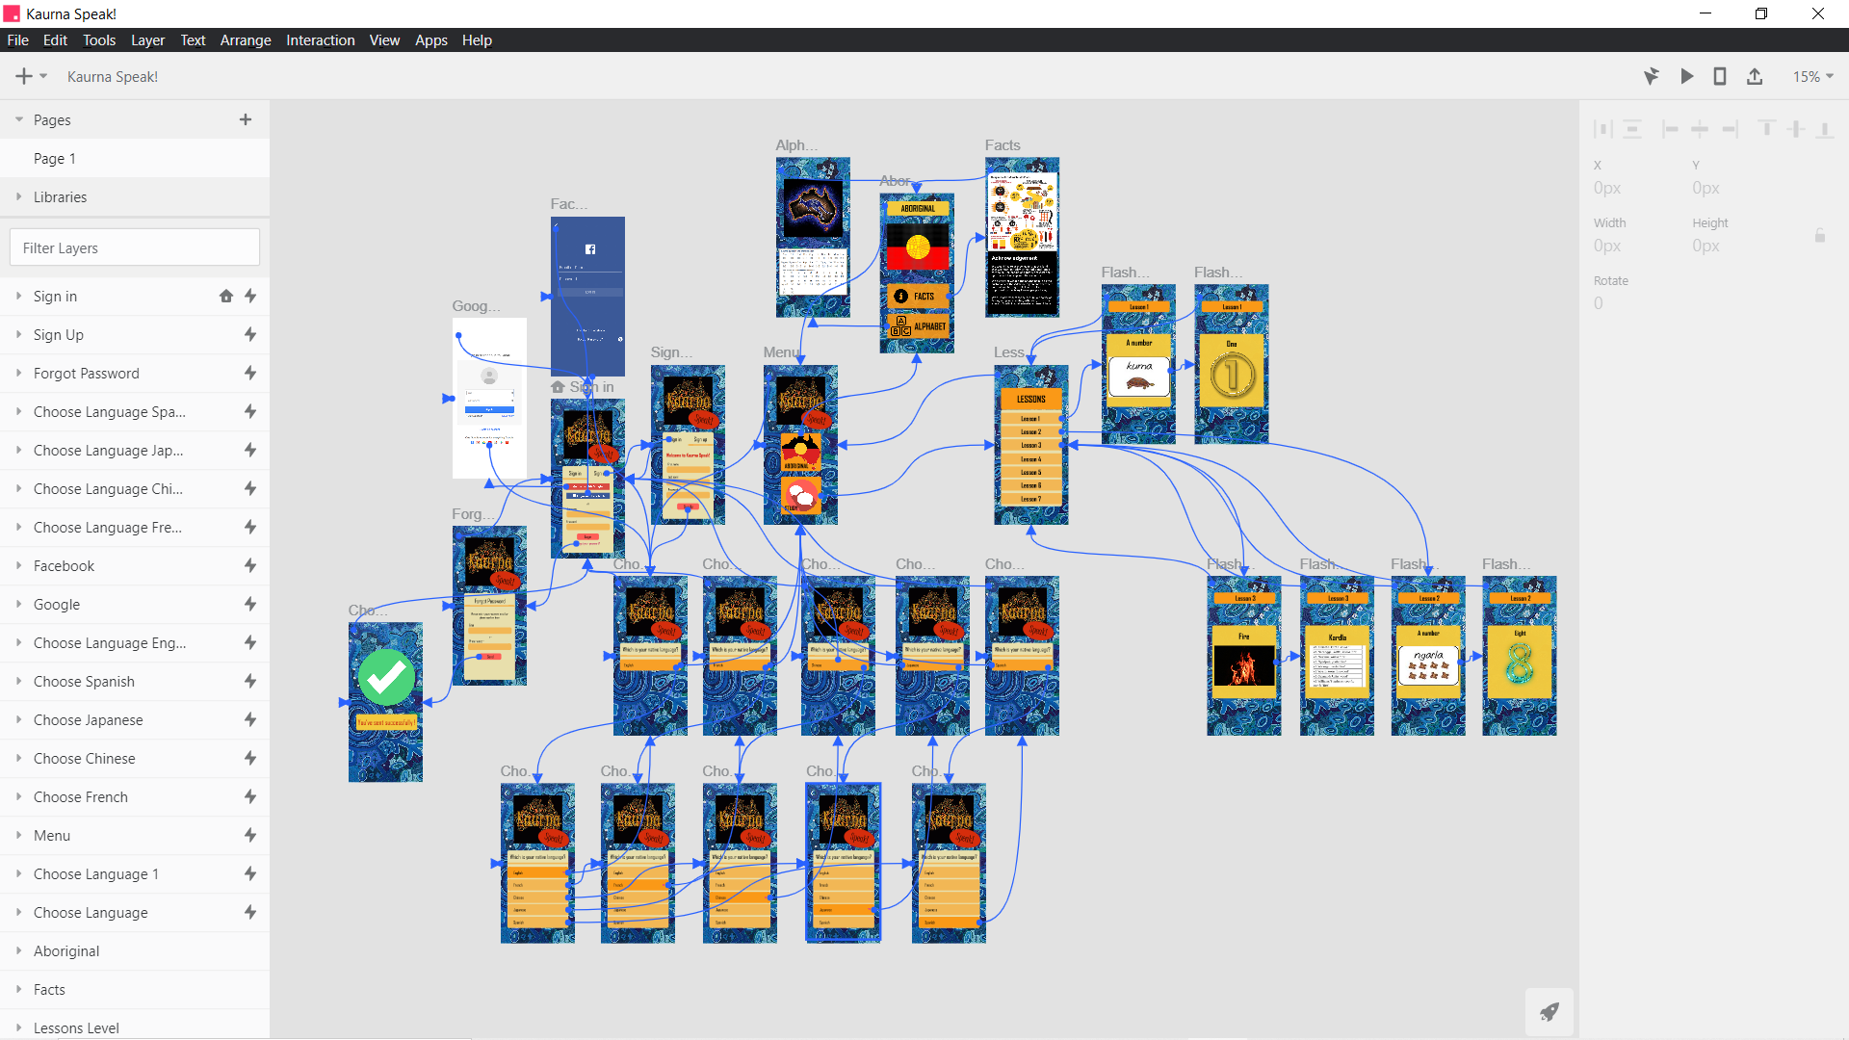

Here is the video of this prototype

[Video](https://drive.google.com/file/d/1hpZuGlbEwT4hG-_DxTGSetVLZsc53CRn/view)

**An**

**TEST– STAGE 5 OF DESIGN THINKING PROCESS**

Preference

<https://careerfoundry.com/en/blog/ux-design/user-testing-design-thinking/>

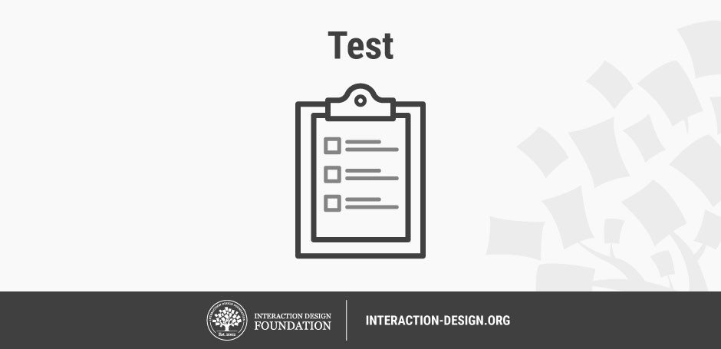

Author/Copyright holder: Teo Yu Siang and Interaction Design Foundation. Copyright licence: CC BY-NC-SA 3.0

*“Designers or evaluators rigorously test the complete product using the best solutions identified during the prototyping phase. This is the final stage of the 5 stage-model, but in an iterative process, the results generated during the testing phase are often used to redefine one or more problems and inform the understanding of the users, the conditions of use, how people think, behave, and feel, and to empathise. Even during this phase, alterations and refinements are made in order to rule out problem solutions and derive as deep an understanding of the product and its users as possible.”*

**Test**

There are a wide range of testing methods available to designers during a [Design Thinking](https://www.interaction-design.org/literature/topics/design-thinking) project; many of which stem from the methodologies typically used during Human-computer interaction (HCI) and User-centered design (UCD) tests. At the heart of these methods, during the Design Thinking process, there is a need to [test](https://www.interaction-design.org/literature/topics/test) out the solutions implemented within the current design. If users experience difficulties, then the design team must revisit their list of potential solutions and strategies in order to establish new ways of solving the same problems. User feedback is priceless; without an understanding of what users need in order to carry out specific activities and tasks, the iterative process will fail. Each stage should provide new insights to inform your understanding and help you define or redefine the various problems that the users might face. Therefore, you must seek feedback whenever possible, use real people for testing purposes, and analyse results in order to determine what is right and what is wrong with the product.

Testing can be undertaken throughout the progress of a Design Thinking project, although it is most commonly undertaken concurrently with the [Prototyping](https://www.interaction-design.org/literature/topics/prototyping) stage. Testing, in Design Thinking, involves generating user feedback as related to the prototypes you have developed, as well as gaining a deeper understanding of your users. When undertaken correctly, the Testing stage of the project can often feed into most stages of the Design Thinking process: it allows you to Empathise and gain a better understanding of your users; it may lead to insights that change the way you Define your [problem statement](https://www.interaction-design.org/literature/topics/problem-statement); it may generate new ideas in the Ideation stage; and finally, it might lead to an iteration of your Prototype.

## **The Iterative, Flexible (and Messy) Design Thinking Process**



*Testing can be undertaken throughout the progress of a Design Thinking project, although it is most commonly undertaken concurrently with the Prototyping stage.*

The five stages of Design Thinking — Empathise, Define, Ideate, Prototype and Test — are not meant to be sequential steps to be taken as the project progresses. Instead, they are “modes” that you can take on during each phase of your project (sometimes in parallel or in iterative loops), as and when they would facilitate the most learning and value.

For instance, prototyping can be undertaken early on in the project — ahead of ideation — in order to discover more about the users. Simple prototypes can be developed, not just to test ideas, but to understand more about how users operate on a daily basis. For example, the Prototyping stage could feed into the Empathise stage.

Another example relates to the way the Testing stage could feed into the Define stage. For instance, your observations of users in tests may reveal crucial insights that could change the way you frame the problem statement.

Design Thinking is a flexible and iterative process that can be messy and disorienting to those who are unfamiliar. While there are no fixed, sequential steps to follow, there are nonetheless basic building blocks behind each stage that help you build human-centered solutions to the problems your users face.

## **Conducting a User Test**

When conducting a user test on your prototype, it is ideal to utilise a natural setting (i.e., the normal environment in which your users would use the prototype). If testing in a natural setting proves difficult, try to get users to perform a task, or play a role, when testing the prototype. The key is to get users to be using the prototype as they would in real life, as much as possible.

## **How to conduct user testing: A step-by-step guide**

Now you’re familiar with some common user testing methods, let’s get down to the logistics. When it comes to running user tests, there are certain steps you need to follow—regardless of your chosen method:

1. **Set an objective:**

The very first thing you’ll need to do is set a clear objective. What do you want to learn from your user tests? What question do you hope to answer? Setting a clear objective will help you to build the right kind of prototype and choose the most appropriate user testing method. For example: If you’re designing an ecommerce app, your objective might be to test how easy it is for your users to add an item to their Wishlist.

1. **Build your prototype:**

You know what you want to test; now it’s time to build your prototype. If you’re in the very early stages of testing an idea, you’ll stick to low-fidelity prototypes. Once you’ve decided on a concept, you’ll want to test the finer details, such as information architecture or [microcopy](https://careerfoundry.com/en/blog/ux-design/what-is-microcopy-ux/), using mid and high-fidelity prototypes.

1. **Create a plan:**

For the sake of consistency, it’s important to create a plan for your user testing session. Your plan should include your objective or question; the method you intend to use to test your prototype; the number of users you’ll test on; a list of all the equipment you’ll need; and how you’ll document and measure your findings. Depending on your chosen method, you may also want to create a script in order to keep the session focused.

1. **Recruit participants:**

Another crucial aspect of user testing is recruiting the right participants. You want to test on users who represent your target audience, so spend a bit of time identifying some key criteria. If you’re designing an over-50s dating app, for example, it wouldn’t make sense to run user tests with a group of 18-year-olds.

1. **Gather all the necessary equipment:**

Having recruited your participants, you’re ready to get the session underway. Refer to your plan and make sure you’ve got everything you need to conduct the tests: screen recording software if you’re conducting remote testing, pens and paper for taking notes, and, of course, your prototype!

1. **Document your findings:**

Throughout each user test, be sure to document your findings. You’ll need a thorough record of each test in order to analyse your observations and compare the results of each session.

### **Improve Your Test Results**

Conducting a test is not as simple as getting the user and the prototype in the same room and watching what happens. In order to achieve the best learning results from each test, here are some areas of a test that you should take into consideration:

* + **The prototype**  
    Remember that you are testing the *prototype*, not the user. Your prototype should be designed with a central question in mind — a question that you will put to the test in the testing stage.
  + **Context and scenario**  
    As much as possible, try to recreate the scenario in which your users are most likely to be using the product. This way, you can learn more about the interaction (or disruptions) between the user, the prototype and the environment, as well as how problems might arise as a result of that interaction.
  + **How you interact with the user**  
    Make sure your users know what the prototype and test are about, but do not over-explain how the prototype works.
  + **How you observe and capture feedback**  
    While collecting feedback, make sure you are not disrupting the user’s interaction with the prototype. Find a way to collect feedback in a way that freely allows you to observe what is happening (for example, by having a partner in the test, or by recording an audio or video of the test).

By being deliberate about those four aspects of a test, you will be able to maximise your learning experience. Considering the above points, here are a few things you can do to help you properly plan your tests. We’ve summed these things up in the guidelines outlined below.

### **5 Guidelines when Planning a Test**

1. **Let your users compare alternatives**  
   Create multiple prototypes, each with a change in variable, so that your users can compare prototypes and tell you which they prefer (and which they don’t). Users often find it easier to elucidate what they like and dislike about prototypes when they can compare, rather than if there was only one to interact with.
2. **Show, don’t tell let your users experience the prototype**  
   Avoid over-explaining how your prototype works, or how it is supposed to solve your user’s problems. Let the users’ experience in using the prototype speak for itself and observe their reactions.
3. **Ask users to talk through their experience**

When users are exploring and using the prototype, ask them to tell you what they’re thinking. This may take some getting used to for most users, so it may be a good idea to chat about an unrelated topic, and then prompt them by asking them questions such as, “What are you thinking right now as you are doing this?”

1. **Observe**  
   Observe how your users use — either “correctly” or “incorrectly” — your prototype and try to resist the urge to correct them when they misinterpret how it’s supposed to be used. User mistakes are valuable learning opportunities. Remember that you are testing the prototype, not the user.
2. **Ask to follow up questions**  
   Always follow up with questions, even if you think you know what the user means. Ask questions such as, “What do you mean when you say ___?”, “How did that make you feel?”, and most importantly, “Why?”

*Remember that you are testing the prototype, not the user. Your prototype should be designed with a central question in mind — a question that you will put to the test during the testing stage.* *Make sure your users know what the prototype and test is about, but do not over-explain how the prototype works.*

**Negative Feedback is Your Way to Learn and Improve**

If users experience difficulties, the design team must revisit their list of potential solutions and strategies in order to establish new ways to solve the same problems. Testing can also help identify previously unconsidered problems. Testing sessions are most fruitful when they are carefully planned and organized. The users’ feedback is priceless; without an understanding of what users need in order to carry out their activities and tasks, the iterative [design process](https://www.interaction-design.org/literature/topics/design-process) and solution will fail. As with each stage in a Design Thinking process, testing should provide new insights to inform your understanding and to help you define or redefine the various problems that the users might face. Therefore, you must seek feedback wherever possible, conduct tests using real people, and analyse the results to determine what is working well and what is causing problems. And always remember that:

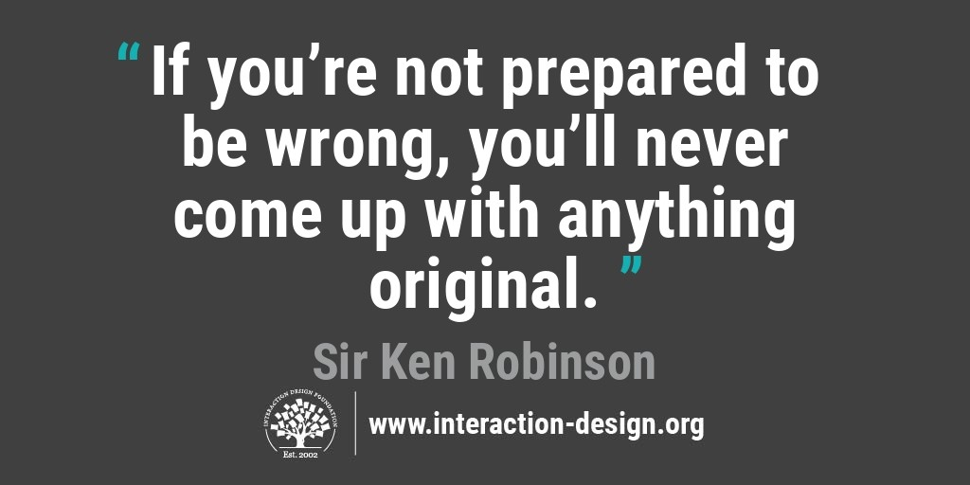Author/Copyright holder: Teo Yu Siang and [Interaction Design Foundation](https://www.interaction-design.org/literature/topics/interaction-design-foundation). Copyright terms and licence: CC BY-NC-SA 3.0

## **The End Goal: Desirable, Feasible, and Viable Solutions**

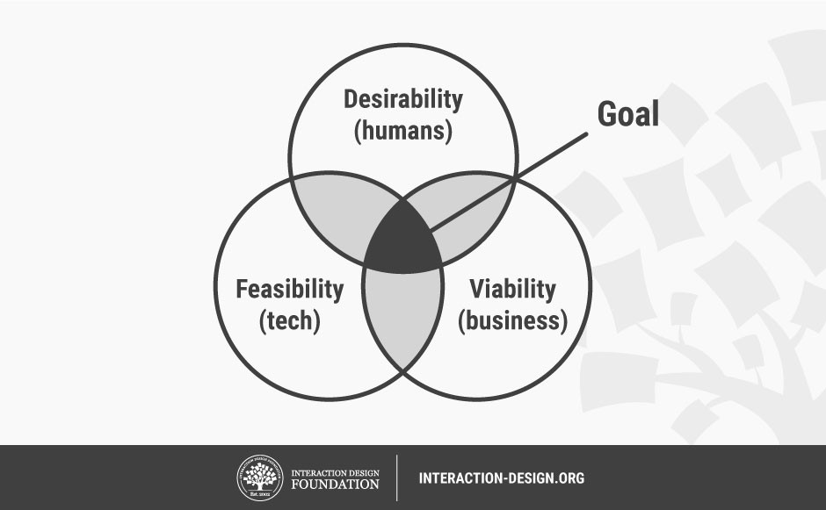Author/Copyright holder: Teo Yu Siang and Interaction Design Foundation. Copyright terms and licence: CC BY-NC-SA 3.0

Design Thinking is a human-centred design process that may not have a fixed sequence of steps but will certainly have an ideal end point. The end goal of every Design Thinking project is to design a solution that satisfies the tests of [desirability](https://www.interaction-design.org/literature/topics/desirability), feasibility, and [viability](https://www.interaction-design.org/literature/topics/viability).

* + **Desirability relates to the focus on people**; it’s what puts the “human” in human-centred design. If a solution is to be desirable, it has to appeal to the needs, emotions, and behaviours of the people we are designing for.
  + **Feasibility is about technology**. Is your design solution technically possible, or does it depend on a technology that’s yet to be invented (or good enough for regular use)? While we should never base designs on technical specifications, our design solutions need to be practical and implementable without incurring huge costs.
  + **The last test is (commercial) viability: will your design solution work as a business?** Is there an appropriate business model behind your solution, or would it collapse after a few years without investor or donor contributions? Design Thinking is not about making a profit, but [good design](https://www.interaction-design.org/literature/topics/good-design) solutions should always be self-sustaining — Design Thinking is a long-term process that should ideally continue supporting and improving itself way beyond the project deadline.

When you are able to create a prototype (or finished product or service) that satisfies the desirability, feasibility, and viability tests, pat yourself on the back, congratulate your team, or even do a small dance if you like: you’ve designed a solution that will impact people around you for the better, and one that will continue to improve lives in the years to come.

## **Conclusion**

Testing is the fifth stage in the five-stage Design Thinking process. Testing is often undertaken concurrently with Prototyping, and performed well, it can provide many learning opportunities to help you learn more about the user, and opportunities to refine your prototype and even the problem statement. When conducting tests, you should pay attention to the prototype, the context and scenario in which you are testing, how you interact with the user, and how you observe and collect feedback. To help you plan a test, there are several guidelines you can follow:

1. **Let your users compare alternatives**
2. **Show, don’t tell let your users experience the prototype**
3. **Ask users to talk through their experience**
4. **Observe**
5. **Ask to follow up questions**

And finally, the Design Thinking process is fluid, iterative and flexible: the different stages often feed into one another and form iterative loops, and don’t necessarily follow any sequence in a project. That said, the ideal end point of Design Thinking (when you know you’ve done a great job) is when the product or service satisfies the three tests of desirability, feasibility, and viability.

We expect to see one stand-up meeting for each day the project was running (except weekends and public holidays).

|  |  |  |
| --- | --- | --- |
| Date | Link | Who participated? |
| 3/09/2020 |  | Meeting cancelled as only a small number of team members were available at the time of the meeting. |
|  |  |  |
| 04/09/20 - |  | <https://youtu.be/h05pJdHYFDg>  https://youtu.be/h05pJdHYFDg  [Stand-Up Meeting 4/09/20](https://www.youtube.com/watch?v=h05pJdHYFDg&feature=youtu.be)  Harpuneet, Kann, Angela, Regina, An, Rojina |
| 08/09/20 |  | https://youtu.be/bU0mFSY5eMQ  [Stand-Up Meeting 8/09/20](https://youtu.be/bU0mFSY5eMQ) |
|  |  |  |
| 09/09/20 |  | [Stand-Up Meeting 9/09/20](https://youtu.be/zHJsFPm0QVY) |
|  |  |  |
| 10/09/20 |  | <https://youtu.be/uw4-Yy-UqhU>  <https://youtu.be/zHJsFPm0QVY> |
| 11/09/20 |  | <https://youtu.be/DLf4AU77YjU> |
| 12/09/20  13/09/20 |  | <https://youtu.be/fMbHQNiVaEs>  <https://youtu.be/ypPB364W3D0>  <https://youtu.be/x2ntQW6K2Wc> |
| 14/09/20 |  | <https://youtu.be/8ebGKWFSD2c>  <https://youtu.be/GKW-zDRa598> |
| 15/09/20  16/09/20  17/09/20  18/09/20 |  | <https://youtu.be/dfd0odlLwoI>  <https://youtu.be/Z2nOvgj7eeA>  <https://youtu.be/pBPPvvjpSYA>  <https://youtu.be/pFtETkCI58s>  <https://youtu.be/WE5C48Ye02I> |

This activity is for everyone

Watch and consider the video on [this page](https://ethics.org.au/how-to-build-good-technology-the-ethics-centre/). Dr Matt Beard from The Ethics Centre at Sydney University provides several reasons why it’s important to consider ethics when designing technical products. He re-frames seven schools of philosophical thought on ethics into universal statements on doing ethics. Then, he provides 8 principles for ethical tech design.

Conduct the following ethical analysis

* Write down the 8 principles for ethical tech design.
* Reflect upon the 8 principles for ethical tech design.
* Evaluate your team’s innovation against the 8 principles.
  + For each principle, provide a few sentences explaining how your innovation excels or fails against the principle.
  + Include things your team could do (if there was enough time) to ensure the innovation is as ethical as possible.

Include the ethical analysis in the team’s shared document, along with a team statement on why it’s important for innovators to consider ethics.

**-Kaan**

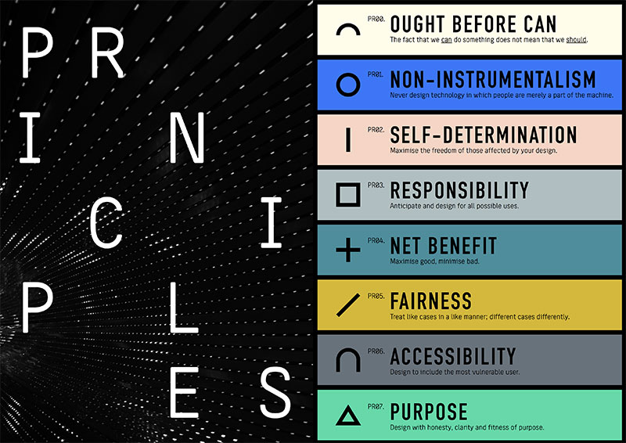

**-Kaan**

**The 8 principals for ethical tech design:**

1. **Ought before can, should before could:**

The designs we do should be to the point. Otherwise, if we add everything we can do, the product will likely lose its efficiency. That’s why we should do the things that will serve to our idea of the purpose of the product. For example, we are going to do a language application to teach the language. While discussing the app, we were considering making another section regarding recycling in the app; however, we decided that there would be too much to cover and the app would lose its efficiency. We could have done it, but we did not for the reason I mentioned above.

1. **Non-instrumental:**

Our main purpose while designing the products should be finding a solution to a problem of a group or a person. Therefore, the people who need the product should be our target audience rather than making them the part of the process so that we can make more profit. With our app, I believe that we are directly addressing an issue where the Kaurna community have concerns about. Thanks to our app, the Kaurna community will benefit the most.

1. **Self-Determination:**

In our designs, we should not try to direct everyone in a particular direction. We should leave open doors for our audiences. At least they should have the right to choose. In our app, we let everyone to choose their native language so that they can learn in the best possible way.

1. **Responsibility:**

We should be responsible for our design. We should not put blames on each other, and we should learn from our mistakes by making improvements to our product. Also, to minimize the mistakes we should take everyone into consideration. For example, we have reading, listening, writing and speaking parts in our app with different types of exercises where any person with any impairment can learn the language as easily as any other person. And those types of exercises make the learning possible anytime and anywhere.

1. **Net Benefit:**

Before finishing the design part, we should do as much testing as possible to maximise the good and minimise the bad because we want the audience to benefit from the product in the best possible way. That’s why it is important to test the product. About our app, we did test and tried different types of prototypes. All in all, it is our essential aim to make the people benefit from it the most and leave no room for any mistake.

**6.Fairness:**

Fairness holds great importance when it comes to the process of the design of any product. We must not single out any group based on their background or physical appearances. I believe that we must take this into consideration especially when it comes to testing stage because it is where the data is collected and subsequently made changes to the design. If it is possible, the people who will participate in the test should vary greatly. Also, our design should enable people from different backgrounds to benefit from the product. As you can see in our design, anyone from with different languages can learn the language easily.

**7.Accessibility:**

Accessibility is one of the most important factors that make the design unique. We should take the places and the people with different impairments into account. Especially these days everyone has access to the internet yet there are some places where the connection is weak and makes it hard to use the product. In our case, we designed our app to be able to function while there is not any internet connection available. Moreover, the people will not worry about their internet data while using the app. Another thing is the design should make it easy for anyone with any impairment to experience the product. That’s why we divided learning into 4 different parts which are reading, listening, writing and speaking.

**8.Purpose:**

The design should be serving to the purpose while the way it is utilized is simple and the designers are not planning to benefit from something else behind the scenes that the people are not aware of. Particularly the simplicity of the product is essential because even if the product serves to the purpose, if it is too complex to use, the people are not going to benefit from it to the fullest. At the same time, we should be sincere about our purpose. Otherwise, we may scare people away such as collecting everyone’s data and selling it to the companies. So, we must be clear about what we are doing. About our app, we made it clear our intention and simplicity is one of our core principals. The design of our app directly serves to a particular purpose regarding language issue.

**ROJINA SHARMA**

**The 8 principles for ethical Techology design are:**

**1.Ought before can, should before could (no hand no play policy):** The fact is we can do something that doesn't mean we should do and this principle applied in our team we can do doesn't mean we should do as working in team we should do together dividing parts not alone , we should take others ideas also and we can select the better one in this way we can get best result. Moreover in our innovation in our app we could do different other functionality but its ineffective and hard to manage everything in one website so we did language only but we did whole aboriginal language instead of doing only Kaurna language thinking it will be more effective And we did same we have applied this ethic principle to get the best result.

**2.Non- instrumental:** Never design technology in which people are merely a part of machine. Some things matter in ways that can’t be measured or reduced to their utility value. People, ecosystems, some kinds of animal life and political communities shouldn’t be used as tools that can be incorporated into design. They must be the beneficiaries of your design, not elements of a machine or design system.

**3.Self-Determination:** Maximize the freedom of those affected by your design. Technology is meant to be an extension of human will. It’s meant to empower us to achieve goals we otherwise couldn’t. Technology can’t achieve this goal if it interferes with our freedom. We need to make design choices that support people’s ability to make free choices about how they want to live and engage with technology. But remember maximising freedom doesn’t always mean maximising choice – sometimes too much choice can be paralysing. In our innovation we need to design it simple and productive so that it will support people and help then in learning the Kaurna language easily but with the productive result.

**4.Responsibility:** Responsibility is one of the most important principle of ethics and we our team are successful with this principle; we each team member know our responsibility. Everyone in the team must accept responsibility for the overall outcomes irrespective of the personal or group perception of the importance of their role. In order to make it easier for the team's goal to be achieved, responsibilities are usually distributed in the form of tasks and same way we have distributed our work taking own responsibility towards project language app ensuring the required information for user to use our app which provide aboriginal history, Kaurna’s alphabet by using reliable resources .

**5.Net benefit:** The things we build should make a positive contribution to the world – they should make it better. But more than this, we should also be mindful of the potentially harmful side-effects of our technology. Even if it does better than bad, ethical design requires us to reduce the negative effects as much as possible. Which mean maximize the good and minimize bad. I think every project, business wants to get success get better result for people out there and same way we are doing our best to do so hopefully our work effort time and knowledge will lead something better for this project. We are giving our best to prove this principle of ethics where our innovation enable user from school students to whoever is interested to know and learn about Kaurna language in a wide range of age.

**6.Fairness:** Treat like cases in like manner, different cases in different manner. Technology designs can carry biases, reflect the status quo or generate blind spots. The implication of this can mean some groups of people are treated negatively based on irrelevant or arbitrary factors such as race, age, gender, ethnicity or any number of unjustifiable considerations. Fairness requires that we present justifications for any differences in the ways our design treats each user group. If some groups do experience greater harm or less benefit than others, we must consider why this is the case and if our reasons are defensible. And our team is successful with this fairness principle of ethics there is no discrimination, negativity, we treat each user with respect. Our innovation is not only for one age range of people or just for some students it is for all user of wide range of age from internal school students to whoever is interested to learn about kaurna language its history, overview, alphabets and the way of using it.

**7.Accessibility:** design to include most vulnerable user. Whenever we have intended users and use cases, we also have people who we don’t intend as users of the technology. This is a risk when design excludes people who might benefit from our design, if we’d only thought of them in the process. Design can reinforce social disadvantage, or it can help people overcome it. But it can only do this if we bear in mind all the possible users, without dismissing some groups as ‘edge cases. The term ‘edge case’ is sometimes used to describe these kinds of people – those who used the technology but are not part of the target audience. Technologists should stop thinking about edge cases. They should not assume they have total say over who their audience is. It isn’t enough to say, “we didn’t design this technology for X group”. If X group has a presumed right to the technology, they ought not to be excluded by design. Our innovation app is for all kind of clients we are designing it as simpler, easier and friendly app rather than making it complex with wide range of functionalities because some of user may not know how to use the app.

**8.Purpose:** Design with honesty clarity and fitness of purpose. Design is, in one sense, a promise. You are promising to solve a problem your users are experiencing. Like all promises, you should honour this promise. You must be honest and clear about the ability and limitations of your design. Moreover, your design should be tailored to the problem it’s trying to solve – and be intended to solve a genuine problem. Good design serves an ethical purpose and does so in efficient and effective ways. Our purpose is to develop a language app that will help to those users who wants to learn about karuna language, its history and the way of using it in simple and easier way for all wide range of age of people.

**An**

**8 PRINCIPLES FOR ETHICAL TECH DESIGN**

**\*** There are 8 principles:

+ **Ought before can**: The fact that we can do something does not mean that we should. Like with our innovation, we could do a website that include the management of diverse aspects such as students’ study record, learn Kaurna language or environment. However, it’s ineffective to manage all that information, and also quite redundant. As the result, we decided just focus on remaining Aboriginal language – Kaurna instead.

+ **Non-instrumentalism**: Never design technology in which people are merely a part of the machine.

+ **Self-determination**: Maximize the freedom of those affected by your design.

+ **Responsibility**: Anticipate and design for all possible uses. Within our innovation, we use reliable resources for the most accurate information which is required for users to use as this is the app that provide Aboriginal history and Kaurna’s alphabet (playing a role as a flashcard learning language app or a dictionary)

+ **Net benefit**: Maximize good, minimize bad. Our innovation enables users, in a wide range of age, from internal students in school to whoever is interested in learning about Kaurna, to have an overview about Kaurna’s alphabet as well as words’ meanings, its history and several sentences as examples in order to know more about the word’s content and how to use it properly.

+ **Fairness**: Treat like cases in a like manner, different cases differently.

+ **Accessibility**: Design to include the most vulnerable user. As we tend to aim at variety types of clients and some of them have never learnt Kaurna language or even never used learning languages app before, we need to design the friendliest environment for them and enable them to access more easily.

+ **Purpose**: Design with honesty, clarify and fitness of purpose, as same as the Responsible principle

Deshan

**Ought before can**

Potentiality to do something is important and using the potentiality in the right way, right place and right time is vital. When we are designing our language app, we were concentrating only one segment out of customers problems. As a language protection method, we decided to design a app which could help the students to learn about the kaurna language as well as to test their learning outcomes. We could have added more features such as fund-raising segment, monetization via app etc. But we chose to target one main objective to be implemented which is very important for the success of the app.

**Non-Instrumentalism**

An app is designed specially to solve a problem of people. So, after launching an app main target crowd is the set of customers who are having the issue. Therefor when we design our app/product we should always target the problem affected people as our audience rather than making them part of the app developing process. This could raise the effectiveness of the app which is more important than making huge amount of money.

**Self-Determination**

Protecting and enhancing the freedom in the app for the customers is important to make right choices on their own. We can’t force them to what to do through the app. As a language app we have given the users to learn the language in their own comfortable languages. Customer feedback plays a key role here as much we give the users the freedom the much, we get real outcome of the app.

**Responsibility**

As a team all the members are having different responsibilities. Responsibility to complete tasks which have assigned individually, as a team to complete the project on time and successfully, responsible for the outcome after the launch of the app, making the app with most accurate information etc. will be key responsibilities members have to bear as a team and individually. What we believe is we have understood our responsibilities in the correct way and doing their best to complete the project as planned.

**Net Benefit**

What we design should always give the word the best and should eliminate negative impacts as much as possible. Our target crowd is students which needs to be extreme careful about side effects from our development. Students could use this in a wrong which will create a negative image upon the app. So, we need to minimize as much as possible. Always our app should give the positive things to the society and we have understood about it and have taken measures to eradicate negative impacts.

**Fairness**

Discriminations should not be allowed through technological products. Each product should be able use by any user other than any negative impact because of using it. Our design team has understood this very well and we are designing our app for all the local students without any age differentiation, race, gender etc. Students who are willing to use, learn about Kaurna language could use the app to get the maximum.

**Accessibility**

Our target audience is school students. So, keeping the things simpler is essential. Making the app complicated reduces the student engagement on the app. We are developing the app with simple login credentials but secured, simple user interface, easy access to study materials etc. As we are targeting all most all the students from primary to high school, we have understood that keeping everything simple is one of the key elements this app and making every student comfortable with app with necessary support.

**Purpose**

Defining the ultimate purpose of the design project is essential for the designing team to do their best. A project is planned to solve a problem of people and to solve the problem designing team gives a better solution which can use by any of the problem experienced users. Also, the solution you are presenting should be promising for the users although there can be imperfections which need to be admitted by the design team. Our project’s main aim is to design a language app which help the students to learn about Kaurna language with easy guidelines to make the progress during the study period without any limitations on type of the user.

**Angela: Principles For ethical tech design.**

Knowing what's right, wanting what's right and nourishing what's right.

**1.Ought before can – The fact that we can do something does not mean that we should.**

Despite having the right idea and ability to create something, to be truly ethical we must ask if it's our responsibility to create it. When creating the Kaurna Language app, we as a team must be very careful in not taking ownership of the language as we are not the traditional owners of the language and the land we are living and studying on. However, working with the Kaurna community to keep help keep the language alive and giving an acknowledgement to country and proper credit to the elders that has helped with reciting the dialect is an ethical way of dealing with the project.

**2.Self Determination – Maximize the freedom of those affected by your design**

The team has decided upon a free app, to create an app for students to learn the Kaurna Language. This decision is positively impacting students who want or need the app to help with their studies but are limited in purchase ability. This is creating a more ethical approach as we are considering all aspects to those affected by our design.

**3.Net Benefit-Maximise good, minimize bad.**

Through the creation of the app we are keeping an ancient language alive this is thus maximising good.

**4.Accessibility -Design to include the most vulnerable user.**

This is similar to that of Net Benefit and Self Determination; The creation of a free and easily accessible app for students in and out of school to keep a ancient language alive. To best create a chance of the app being used is to create a simple and effective program. This is so all times of people are able to fully enjoy the benefits of the application and the Kaurna Language.

**5.Non-instrumental- Never design technology in which people are merely a part of the machine.**

During the development of the application we will make sure to work with the community for the community and not to do it for brownie points. These are real people who are affected by a “forgotten tongue” thus this should be created for them and not to look good.

**6.Responsibility - Anticipate and design for all possible uses.**

During the app development it is our responsibility to give the users a comfortable experience on the app.

**7.Fairness - Treat like cases in a like manner; different cases differently.**

The topic of languages is a sensitive issue and must be handled accordingly thus giving factual and useful educational tools and Kaurna Language is very important.

8.Purpose - Design with honesty, clarify and fitness of purpose.

The purpose is to create a surge in interest in the language as well as creating an all in one place to learn it.

HARPUNEET - Pitch

**First task:**

* Which had the greatest style?
* *Greatest style has to be UBER Eats approach of learning what the User wants through the app, visiting restaurants, food markets, riding with the UBER delivery partner (not literally). This for me a brilliant way to understand what the demand is, what area the demand is higher than other. Perfect way to seek and Supply.*
* Which had the greatest content?
* *Understanding Empathy and why It’s needed in Design thinking was a great article. This helped our team be use empathy as a tool and focus on our client’s story and their pain points. Article also sheds light on Cognitive Empathy too. This helped in understanding the pain points without sharing the same emotions. This in return helps to deliver a better project/solution.*
* Is there one talk that stands out in your memory?
* *One that stands out will have to be Ted talk by Tim Brown. It talks about why understanding client context is important for Design thinking. If one has the context in mind you will design whatever the client has requested and not stray off path.*

**Second task:**

Team positive aspects- Team learned how to appropriately use empathy after watching client video used client context to come up with a solution. Keeping context in mind we were quickly able to come to an agreement what we were going to present and how it will help the school and the students.

**Third Task:**

Resource 1**-**

* By Focusing on what the key message and remove all unwanted material. Focus on keeping the audience hooked on the pitch by using interesting ideas.

Resource 2-

* Review the goal of the pitch. Write a story about the pitch and tell it how it works for the audience. Practice and correct delivery order will help put an amazing pitch.

Resource 3-

* Simplicity
* Clarity
* Focus
* Breaking things in 3s is the best idea. It's easy for the audience to remember what your pitch was.

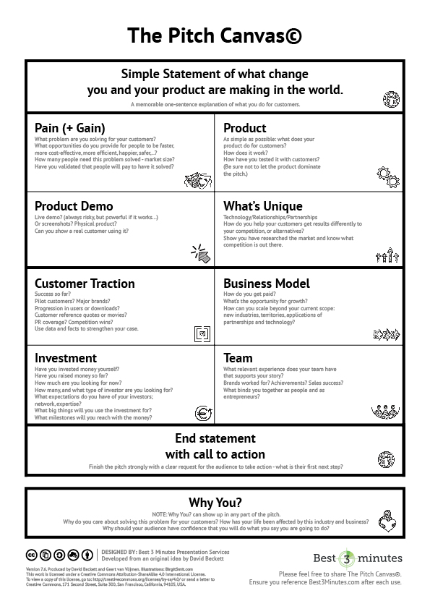

Resource 4-

* Topic explains that one should always prepare to be rejected by the client, managers etc we can better prepare or influence and presenting idea, so it has higher chance of getting accepted. Keeping a pitch simpler will have higher chances of acceptance too.
* Something stood out to me in this article “Getting along with a team is certainly important, but you also need a structure and a culture, where it's okay to speak up or speak out, about products problems, or what's called task-oriented conflict. As we're in the process of making something better, it's okay to argue and to challenge.” - Certainly, our team had had the experience where we had different view, we listened to each other and came up with a solution that suited the client.

Resource 5-

* Provide direct solution, articulate the problem, listing relevant features for the product in simple terms is the winning formula. The whole team’s effort should be acknowledged in the pitch to show how everyone came together with the idea that’s being pitched.

**Fourth Task:**

After reviewing these resources, I think we should stick to:

* Our goal.
* Keep it simple.
* Clear and simple pitch for the audience.
* Focus on the message.
* Acknowledge everyone’s work.

**Fifth Task:**

Topic:

* Introduction of the team

Subtopic:

* How we identified the problem.
* How did we arrive at this solution.
* Why we think this idea is worth pitching
* How can we keep improving it in future.

**Sixth Task:**

Day of the Pitch.

1. Various CEOs and CIOs from the IT industry advised the university to include this course in your program.
2. Participating means that you listen carefully to what others are saying, you speak when it’s your turn, and you make a sensible contribution to discussions at EVERY opportunity.